2026
State & Local Minimum Fire Safe Regulations Guide
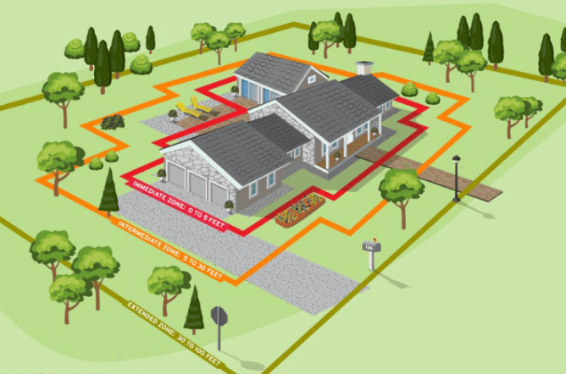

THESE GUIDELINES ARE FOR INFORMATIONAL USE ONLY

View the official California Code of Regulations and local guidelines online at:
https://govt.westlaw.com/calregs/Index

Public Resources Code – PRC
Division 4. Forests, Forestry Range and Forage Lands [4001 - 4958]
Part 2. Protection of Forest, Range and Forage Lands [4101 - 4789.7]
Chapter 2. Hazardous Fire Areas [4251 - 4290.5]

California Code of Regulations
Title 14 Natural Resources
Division 1.5 Department of Forestry
Chapter 7 - Fire Protection
Subchapter 2 State Minimum Fire Safe Regulations 2026 / January – Version 1

California Code, Public Resources Code - PRC § 4290
(a) The board shall adopt regulations implementing minimum fire safety standards related to defensible space that are applicable to state responsibility area lands under the authority of the department, and to lands classified and designated as very high fire hazard severity zones, as defined in subdivision (i) of Section 51177 of the Government Code. These regulations apply to the perimeters and access to all residential, commercial, and industrial building construction within state responsibility areas approved after January 1, 1991, and within lands classified and designated as very high fire hazard severity zones, as defined in subdivision (i) of Section 51177 of the Government Code after July 1, 2021. The board may not adopt building standards, as defined in Section 18909 of the Health and Safety Code, under the authority of this section. As an integral part of fire safety standards, the State Fire Marshal has the authority to adopt regulations for roof coverings and openings into the attic areas of buildings specified in Section 13108.5 of the Health and Safety Code. The regulations apply to the placement of mobile homes as defined by National Fire Protection Association standards. These regulations do not apply where an application for a building permit was filed prior to January 1, 1991, or to parcel or tentative maps or other developments approved prior to January 1, 1991, if the final map for the tentative map is approved within the time prescribed by the local ordinance. The regulations shall include all of the following:
(1) Road standards for fire equipment access.
(2) Standards for signs identifying streets, roads, and buildings.
(3) Minimum private water supply reserves for emergency fire use.
(4) Fuel breaks and greenbelts.
(b) The board shall, on and after July 1, 2021, periodically update regulations for fuel breaks and greenbelts near communities to provide greater fire safety for the perimeters to all residential, commercial, and industrial building construction within state responsibility areas and lands classified and designated as very high fire hazard severity zones, as defined in subdivision (i) of Section 51177 of the Government Code, after July 1, 2021. These regulations shall include measures to preserve undeveloped ridgelines to reduce fire risk and improve fire protection. The board shall, by regulation, define “ridgeline” for purposes of this subdivision.
(c) These regulations do not supersede local regulations which equal or exceed minimum regulations adopted by the state.
(d) The board may enter into contracts with technical experts to meet the requirements of this section.

California Code, Public Resources Code - PRC § 4290.5
(a) On or before July 1, 2021, and every five years thereafter, the board, in consultation with the State Fire Marshal, shall survey local governments, including counties, cities, and fire districts, to identify existing subdivisions located in a state responsibility area or a very high fire hazard severity zone, identified pursuant to Section 51178 of the Government Code, without a secondary egress route that are at significant fire risk.
(b)(1) The board, in consultation with the State Fire Marshal and the local government that identified the subdivision, shall develop recommendations to improve the subdivision's fire safety. The recommendations may include, but are not limited to, the following:
(A) Creating secondary access to the subdivision.
(B) Improvements to the existing access road.
(C) Other additional fire safety measures.
(2) The board shall provide the final recommendations developed pursuant to this subdivision to the local government that identified the subdivision and to the residents of the subdivision.
(c) The board may enter into contracts with an independent group to conduct the survey required in subdivision (a).
(d) For purposes of this section, “subdivision” means an existing residential development of more than 30 dwelling units.
(e) The board shall maintain a list of the subdivisions identified in subdivision (a) and the status of the implementation of recommendations provided pursuant to subdivision (b).

California Code, Public Resources Code - PRC § 4291
(a) A person who owns, leases, controls, operates, or maintains a building or structure in the state responsibility area shall at all times do all of the following:
(1)(A) Maintain defensible space of 100 feet from each side and from the front and rear of the structure, but not beyond the property line, except as provided in subparagraph (B). The amount of fuel modification necessary shall consider the flammability of the structure as affected by building material, building standards, location, and type of vegetation. Fuels shall be maintained and spaced in a condition so that wildfire would be unlikely to ignite the structure. This subparagraph does not apply to single specimens of trees or other vegetation that are well-pruned and maintained so as to effectively manage fuels and not form a means of rapidly transmitting fire from other nearby vegetation to a structure or from a structure to other nearby vegetation or to interrupt the advance of embers toward a structure. The intensity of fuels management may vary within the 100-foot perimeter of the structure, with more intense fuel reductions being utilized between 5 and 30 feet around the structure, and an ember-resistant zone being required within 5 feet of the structure, based on regulations promulgated by the board, in consultation with the department, to consider the elimination of materials in the ember-resistant zone that would likely be ignited by embers. The regulations may also alter the fuel reduction required between 5 and 30 feet to integrate the ember-resistant zone into the requirements of this section. Consistent with fuels management objectives, steps should be taken to minimize erosion, soil disturbance, and the spread of flammable nonnative grasses and weeds. For purposes of this subparagraph, “fuel” means any combustible material, including petroleum-based products, cultivated landscape plants, grasses, and weeds, and wildland vegetation.
(B) A greater distance than that required under subparagraph (A) may be required by state law, local ordinance, rule, or regulation. Fuel modification beyond the property line may only be required by state law, local ordinance, rule, or regulation in order to maintain 100 feet of defensible space from a structure. Fuel modification on adjacent property shall only be conducted following written consent by the adjacent landowner. Any local ordinance related to fuel modification shall be in compliance with all applicable state laws, regulations, and policies. Any local ordinance may include provisions to allocate costs for any fuel modification beyond the property line.
(C) An insurance company that insures an occupied dwelling or occupied structure may require a greater distance than that required under subparagraph (A) if a fire expert, designated by the director, provides findings that the fuel modification is necessary to significantly reduce the risk of transmission of flame or heat sufficient to ignite the structure, and there is no other feasible mitigation measure possible to reduce the risk of ignition or spread of wildfire to the structure. The greater distance may not be beyond the property line unless allowed by state law, local ordinance, rule, or regulation.
(2) Remove that portion of a tree that extends within 10 feet of the outlet of a chimney or stovepipe.
(3) Maintain a tree, shrub, or other plant adjacent to or overhanging a building free of dead or dying wood.
(4) Maintain the roof of a structure free of leaves, needles, or other vegetative materials.
(5) Before constructing a new building or structure or rebuilding a building or structure damaged by a fire in an area subject to this section, the construction or rebuilding of which requires a building permit, the owner shall obtain a certification from the local building official that the dwelling or structure, as proposed to be built, complies with all applicable state and local building standards, including those described in subdivision (b) of Section 51189 of the Government Code, and shall provide a copy of the certification, upon request, to the insurer providing course of construction insurance coverage for the building or structure. Upon completion of the construction or rebuilding, the owner shall obtain from the local building official, a copy of the final inspection report that demonstrates that the dwelling or structure was constructed in compliance with all applicable state and local building standards, including those described in subdivision (b) of Section 51189 of the Government Code, and shall provide a copy of the report, upon request, to the property insurance carrier that insures the dwelling or structure.
(b) A person is not required under this section to manage fuels on land if that person does not have the legal right to manage fuels, nor is a person required to enter upon or to alter property that is owned by any other person without the consent of the owner of the property.
(c)(1) Except as provided in Section 18930 of the Health and Safety Code, the State Fire Marshal may adopt regulations exempting a structure with an exterior constructed entirely of nonflammable materials, or, conditioned upon the contents and composition of the structure, the director may vary the requirements respecting the removing or clearing away of flammable vegetation or other combustible growth with respect to the area surrounding those structures.
(2) An exemption or variance under paragraph (1) shall not apply unless and until the occupant of the structure, or if there is not an occupant, the owner of the structure, files with the State Fire Marshal, in a form as the State Fire Marshal shall prescribe, a written consent to the inspection of the interior and contents of the structure to ascertain whether this section and the regulations adopted under this section are complied with at all times.
(d) The State Fire Marshal may authorize the removal of vegetation that is not consistent with the standards of this section. The State Fire Marshal may prescribe a procedure for the removal of that vegetation and make the expense a lien upon the building, structure, or grounds, in the same manner that is applicable to a legislative body under Section 51186 of the Government Code.
(e)(1) The board, in consultation with the State Fire Marshal, shall develop, periodically update, and post on its internet website a guidance document on fuels management pursuant to this chapter. The guidance document shall include, but not be limited to, regionally appropriate vegetation management suggestions that preserve and restore native species that are fire resistant or drought tolerant, or both, minimize erosion, minimize water consumption, and permit trees near homes for shade, aesthetics, and habitat; and suggestions to minimize or eliminate the risk of flammability of nonvegetative sources of combustion, such as woodpiles, propane tanks, decks, outdoor furniture, barbecue equipment, and outdoor fire pits.
(2) On or before January 1, 2023, the board, in consultation with the State Fire Marshal, shall update the guidance document to include suggestions for creating an ember-resistant zone within five feet of a structure, based on regulations promulgated by the board, in consultation with the department, to consider the elimination of materials in the ember-resistant zone that would likely be ignited by embers. Existing and new structures shall meet the same standard for the ember-resistant zone, but regulations shall allow the staging of work for existing structures to support implementation of the ember-resistant zone and address the costs of compliance.
(f) The State Fire Marshal shall do both of the following:
(1) Recommend to the board the types of vegetation or fuel that are to be excluded from an ember-resistant zone based on the probability that vegetation and fuel will lead to ignition by ember of a structure as a part of the update to the guidance document pursuant to paragraph (2) of subdivision (e).
(2) Make reasonable efforts to provide notice to affected residents describing the requirements added by the amendments to paragraph (1) of subdivision (a) made in Assembly Bill 3074 of the 2019-20 Regular Session before the imposition of penalties for violating those requirements.
(g)(1) The requirement for an ember-resistant zone pursuant to paragraph (1) of subdivision (a) shall not take effect for new structures until the board updates the regulations, pursuant to paragraph (1) of subdivision (a), and the guidance document, pursuant to paragraph (2) of subdivision (e).
(2) The requirement for an ember-resistant zone pursuant to paragraph (1) of subdivision (a) shall take effect for existing structures three years after the effective date for the new structures.
(h) The department shall not change defensible space inspection practices and forms or enforcement to implement the requirement for an ember-resistant zone until the State Fire Marshal makes a written finding, which the State Fire Marshal shall post on the department's internet website, that the Legislature has appropriate resources to do so.
(i) For purposes of this section, a structure for the purpose of an ember-resistant zone shall include any attached deck. This section does not limit the authority of the board or the department to require the removal of fuel or vegetation on top of or underneath a deck pursuant to this section.
(j) As used in this section, “person” means a private individual, organization, partnership, limited liability company, or corporation.

4291.3. (a) Subject to any other applicable law, a state or local fire official, at their discretion, may authorize an owner of property, or the owner’s agent, to construct a firebreak, or implement appropriate vegetation management techniques, to ensure that defensible space is adequate for the protection of a hospital, adult residential care facility, school, aboveground storage tank, hazardous materials facility, or similar facility on the property. The firebreak may be for a radius of up to 300 feet from the facility, or to the property line, whichever distance is shorter.
(b) The director may authorize an owner of a property not listed in subdivision (a) to construct a firebreak, or implement appropriate vegetation management techniques, within a radius of up to 300 feet from a structure, or to the property line, whichever distance is shorter, if it is determined by the director as necessary to protect life, property, and natural resources from unreasonable risks associated with wildland fires.


300 Foot Radius
300 Foot Radius
300 Foot Radius

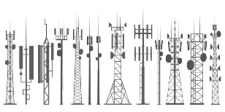
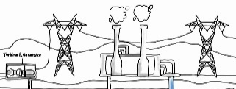

Communication Facilities Environmental Health Electrical CERS Reporters Generation
CUPA Reporters Distribution
Haz Mat Facilities Facilities

Special Consideration:
If your project involves reportable quantities of fuel, propane, batteries, herbicides, pesticides, flammable, explosive, reactive chemicals, or similar materials, you may be required to submit a Hazardous Materials Business Plan (HMBP) to your AHJs Environmental Health as part of their Certified Unified Program Agency (CUPA) Program. In such cases, additional defensible space requirements may apply to your project. You need to find your locations CUPA. Below are links to assist.

https://calepa.ca.gov/cupa/evaluations/

https://osfm.fire.ca.gov/what-we-do/pipeline-safety-and-cupa/certified-unified-program-agency


4427. During any time of the year when burning permits are required in an area pursuant to this article, no person shall use or operate any motor, engine, boiler, stationary equipment, welding equipment, cutting torches, tarpots, or grinding devices from which a spark, fire, or flame may originate, which is located on or near any forest covered land, brush-covered land, or grass-covered land, without doing both of the following: (a) First clearing away all flammable material, including snags, from the area around such operation for a distance of 10 feet. (b) Maintain one serviceable round point shovel with an overall length of not less than forty-six (46) inches and one backpack pump water-type fire extinguisher fully equipped and ready for use at the immediate area during the operation.

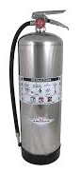
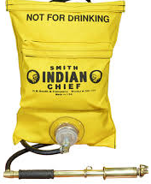
or 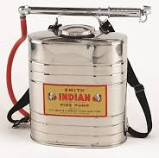 or


and
10 Foot Radius

Special Consideration:
Water extinguishers shall contain a minimum combined total of 5 gallons of water.

4431. During any time of the year when burning permits are required in an area pursuant to this article, no person shall use or operate or cause to be operated in the area any portable saw, auger, drill, tamper, or other portable tool powered by a gasoline- internal combustion engine on or near any forest-covered land, brush covered land. Or grass-covered land, within 25 feet of any flammable material, without providing and maintaining at the immediate locations of use or operation of the saw or tool, for firefighting purposes one serviceable round point shovel, with an overall length
of not less than 46 inches, or one serviceable fire extinguisher. The Director of Forestry and Fire Protection shall by administrative regulation specify the type and size of fire extinguisher necessary to provide at least minimum assurance of controlling fire caused by use of portable power tools under various climatic and fuel conditions. The required fire tools shall at no time be farther from the point of operation of the power saw or tool than 25 feet with unrestricted access for the operator from the point of operation.

or or

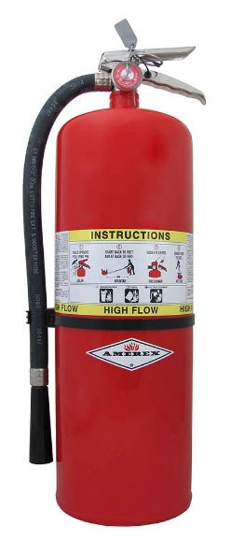

25 Foot Radius



and and

Special Consideration:
Water extinguishers shall contain a minimum combined total of 5 gallons of water. Dry chemical extinguishers should be a minimum of 5 pound or a 2A-10BC. It is recommended that you have a 20 pound or 10A-120BC dry chemical extinguisher.

Contents
Article 1 Administration 10
§ 1270.00. Title 10
§ 1270.01. Definitions 10
§ 1270.02. Purpose 13
§ 1270.03. Scope 13
§ 1270.04. Provisions for Application of these Regulations 14
§ 1270.05. Local Regulations 14
§ 1270.06. Inspections 14
§ 1270.07. Exceptions to Standards 15
§ 1270.08. Distance Measurements 15
Article 2 Ingress and Egress 10
§ 1273.00. Intent 16
§ 1273.01. Width. 16
§ 1273.02. Road Surface 18
§ 1273.03. Grades 21
§ 1273.04. Radius 22
§ 1273.05. Turnarounds 23
§ 1273.06. Turnouts 25
§ 1273.07. Road and Driveway Structures 26
§ 1273.08. Dead-end Roads 28
§ 1273.09. Gate Entrances 29
Article 3 Signing and Building Numbering 33
§ 1274.00. Intent 33
§ 1274.01. Road Signs. 34
§ 1274.02. Road Sign Installation, Location, and Visibility. 38
§ 1274.03. Addresses for Buildings. 40
§ 1274.04. Address Installation, Location, and Visibility. 40
Article 4 Emergency Water Standards 42
§ 1275.00. Intent 42
§ 1275.01. Application 42
§ 1275.02. Water Supply. 42
§ 1275.03. Hydrants and Fire Valves. 46
§ 1275.04. Signing of Water Sources 49
Article 5 Building Siting, Setbacks, and Fuel Modification 49
§ 1276.00 Intent 49
§ 1276.01. Building and Parcel Siting and Setbacks 49
§ 1276.02. Ridgelines 57
§ 1276.03. Fuel Breaks 59
§ 1276.04 Greenbelts, Greenways, Open Spaces and Parks 59
§ 1276.05 Disposal of Flammable Vegetation and Fuels 60

Article 1 Administration

§ 1270.00. Title
Subchapter 2 shall be known as the “State Minimum Fire Safe Regulations,” and shall constitute the minimum Wildfire protection standards of the California Board of Forestry and Fire Protection.

§ 1270.01. Definitions
The following definitions are applicable to Subchapter 2.

(a) Agriculture: Land used for agricultural purposes as defined in a Local Jurisdiction's zoning ordinances.

(b) Board: California Board of Forestry and Fire Protection.

(c) Building: Any Structure used or intended for supporting or sheltering any use or Occupancy, except those classified as Utility and Miscellaneous Group U.

(d) CAL FIRE: California Department of Forestry and Fire Protection.

(e) Dead-end Road: A Road that has only one point of vehicular ingress
s/egress, including cul-de-sacs and Roads that loop back on themselves

(f) Defensible Space: The area within the perimeter of a parcel, Development, neighborhood or community where basic wildland fire protection practices and measures are implemented, providing the key point of defense from an approaching Wildfire or defense against encroaching Wildfires or escaping Structure fires. The perimeter as used in this regulation is the area encompassing the parcel or parcels proposed for construction and/or Development, excluding the physical Structure itself. The area is characterized by the establishment and maintenance of emergency vehicle access, emergency water reserves, Road names and Building identification, and fuel modification measures.

(g) Development: As defined in section 66418.1 of the California Government Code.

(h) Director: Director of the Department of Forestry and Fire Protection or their designee.

(i) Driveway: A vehicular pathway that serves no more than four (4) Residential Units and any number of non-commercial or non-industrial Utility or Miscellaneous Group U Buildings on each parcel. A Driveway shall not serve commercial or industrial uses at any size or scale.

(j) Exception: An alternative to the specified standard requested by the applicant that may be necessary due to health, safety, environmental conditions, physical site limitations or other limiting conditions, such as recorded historical sites, that provides mitigation of the problem.

(k) Fire Apparatus: A vehicle designed to be used under emergency conditions to transport personnel and equipment or to support emergency response, including but not limited to the suppression of fires.

(l) Fire Authority: A fire department, agency, division, district, or other governmental body responsible for regulating and/or enforcing minimum fire safety standards in the Local Jurisdiction.

(m) Fire Hydrant: A valved connection on a water supply or storage system for the purpose of providing water for fire protection and suppression operations.

(n) Fuel Break: A strategically located area where the volume and arrangement of vegetation has been managed to limit fire intensity, fire severity, rate of spread, crown fire potential, and/or ember production.

(o) Greenbelts: open space, parks, wildlands, other areas, or a combination thereof, as designated by Local Jurisdictions, which are in, surround, or are adjacent to a city or urbanized area, that may function as Fuel Breaks and where Building construction is restricted or prohibited.

(p) Greenways: Linear open spaces or corridors that link parks and neighborhoods within a community through natural or manmade trails and paths.

(q) Hammerhead/T: A “T” shaped, three-point Turnaround space for Fire Apparatus on a Road or Driveway, being no narrower than the Road or Driveway that serves it.

(r) Hazardous Land Use: A land use that presents a significantly elevated potential for the ignition, prolonged duration, or increased intensity of a Wildfire due to the presence of flammable materials, liquids, gases, or other features that initiate or sustain combustion. Such uses are determined by the Local Jurisdiction and may include, but are not limited to, power-generation and distribution facilities; wood processing or storage sites; flammable gas or liquids processing or storage sites; or shooting ranges.

(s) Local Jurisdiction: Any county, city/county agency or department, or any locally authorized district that approves or has the authority to regulate Development.

(t) Municipal-Type Water System: A system having water pipes servicing Fire Hydrants and designed to furnish, over and above domestic consumption, a minimum of 250 gpm (950 L/min) at 20 psi (138 kPa) residual pressure for a two (2) hour duration.

(u) Occupancy: The purpose for which a Building, or part thereof, is used or intended to be used.

(v) One-way Road: A Road that provides a minimum of one Traffic Lane width designed for traffic flow in one direction only.

(w) Residential Unit: Any Building or portion thereof which contains living facilities including provisions for sleeping, eating, cooking and/or sanitation, for one or more persons. Manufactured homes, mobile homes, and factory-built housing are considered Residential Units.

(x) Ridgeline: The line of intersection of two opposing slope aspects running parallel to the long axis of the highest elevation of land; or an area of higher ground separating two adjacent streams or watersheds.

(y) Road: A public or private vehicular pathway to more than four (4) Residential Units, or to any industrial or commercial Occupancy.

(z) Road or Driveway Structures: Bridges, culverts, and other appurtenant Structures which supplement the Traffic Lane or Shoulders.

(aa) Same Practical Effect: As used in this subchapter, means an Exception or alternative with the capability of applying accepted wildland fire suppression strategies and tactics, and provisions for fire fighter safety, including:
(1) access for emergency wildland fire equipment,
(2) safe civilian evacuation,
(3) signing that avoids delays in emergency equipment response,
(4) available and accessible water to effectively attack Wildfire or defend a structure from wildfire, and
(5) fuel modification is sufficient for civilian and fire fighter safety.

(bb) Shoulder: A vehicular pathway adjacent to the Traffic Lane.

(cc) State Responsibility Area (SRA): As defined in Public Resources Code sections 4126-4127; and the California Code of Regulations, title 14, division 1.5, chapter 7, article 1, sections 1220-1220.5.

(dd) Strategic Ridgeline: a Ridgeline identified pursuant to § 1276.02(a) that may support fire suppression activities or where the preservation of the Ridgeline as an Undeveloped Ridgeline would reduce fire risk and improve fire protection.

(ee) Structure: That which is built or constructed or any piece of work artificially built up or composed of parts joined together in some definite manner.

(ff) Traffic Lane: The portion of a Road or Driveway that provides a single line of vehicle travel.

(gg) Turnaround: An area which allows for a safe opposite change of direction for Fire Apparatus at the end of a Road or Driveway.

(hh) Turnout: A widening in a Road or Driveway to allow vehicles to pass.

(ii) Undeveloped Ridgeline: A Ridgeline with no Buildings.

(jj) Utility and Miscellaneous Group U: A Structure of an accessory character or a miscellaneous Structure not classified in any specific Occupancy permitted, constructed, equipped, and maintained to conform to the requirements of Title 24, California Building Standards Code.

(kk) Vertical Clearance: The minimum specified height of a bridge, overhead projection, or vegetation clearance above the Road or Driveway.

(ll) Vertical Curve: A curve at a high or low point of a Road that provides a gradual transition between two Road grades or slopes.

(mm) Very High Fire Hazard Severity Zone (VHFHSZ): As defined in Government Code section 51177(i).

(nn) Wildfire: Has the same meaning as “forest fire” in Public Resources Code Section 4103.

§ 1270.02. Purpose
(a) Subchapter 2 has been prepared and adopted for the purpose of establishing state minimum Wildfire protection standards in conjunction with Building, construction, and Development in the State Responsibility Area (SRA) and, after July 1, 2021, the Very High Fire Hazard Severity Zones, as defined in Government Code §51177(i) (VHFHSZ).
(b) The future design and construction of Structures, subdivisions and Developments in the SRA and, after July 1, 2021, the VHFHSZ shall provide for basic emergency access and perimeter Wildfire protection measures as specified in the following articles.
(c) These standards shall provide emergency access; signing and Building numbering; private water supply reserves for emergency fire use; vegetation modification, Fuel Breaks, Greenbelts, and measures to preserve Undeveloped Ridgelines. Subchapter 2 specifies the minimums for such measures.

§ 1270.03. Scope
(a) Subchapter 2 shall apply to:
(1) the perimeters and access to all residential, commercial, and industrial Building construction within the SRA approved after January 1, 1991, and those approved after July 1, 2021, within the VHFHSZ, except as set forth below in subsection (b).
(2) the siting of newly installed commercial modulars, manufactured homes, mobile homes, and factory-built housing, as defined in Health and Safety Code sections 18001.8, 18007, 18008, and 19971.
(3) all tentative and parcel maps or other Developments approved after January 1, 1991; and
(4) applications for Building permits on a parcel approved in a pre-1991 parcel or tentative map to the extent that conditions relating to the perimeters and access to the buildings were not imposed as part of the approval of the parcel or tentative map.
(b) Subchapter 2 does not apply where an application for a Building permit is filed after January 1, 1991 for Building construction on a parcel that was formed from a parcel map or tentative map (if the final map for the tentative map is approved within the time prescribed by the local ordinance) approved prior to January 1, 1991, to the extent that conditions relating to the perimeters and access to the Buildings were imposed by the parcel map or final tentative map approved prior to January 1, 1991.
(c) Affected activities include, but are not limited to:
(1) permitting or approval of new parcels, excluding lot line adjustments as specified in Government Code (GC) section 66412(d);
(2) application for a Building permit for new construction not relating to an existing Structure;
(3) application for a use permit.
(4) Road construction including construction of a Road that does not currently exist, or extension of an existing Road.

(d) The standards in Subchapter 2 applicable to Roads shall not apply to Roads used solely for Agriculture; mining; or the management of timberland or harvesting of forest products.

§ 1270.04. Provisions for Application of these Regulations
This Subchapter shall be applied as follows:
(a) the Local Jurisdictions shall provide the Director of the California Department of Forestry and Fire Protection (CAL FIRE) or their designee with notice of applications for Building permits, tentative parcel maps, tentative maps, and installation or use permits for construction or Development within the SRA, or if after July 1, 2021, the VHFHSZ.
(b) the Director or their designee may review and make fire protection recommendations on applicable construction or development permits or maps provided by the Local Jurisdiction.
(c) the Local Jurisdiction shall ensure that the applicable sections of this Subchapter become a condition of approval of any applicable construction or Development permit or map.

§ 1270.05. Local Regulations
(a) Subchapter 2 shall serve as the minimum Wildfire protection standards applied in SRA and VHFHSZ. However, Subchapter 2 does not supersede local regulations which equal or exceed the standards of this Subchapter.
(b) A local regulation equals or exceeds the minimum standard of this Subchapter only if, at a minimum, the local regulation also fully complies with the corresponding minimum standard in this Subchapter.
(c) A Local Jurisdiction shall not apply exemptions to Subchapter 2 that are not enumerated in Subchapter 2. Exceptions requested and approved in conformance with § 1270.07 (Exceptions to Standards) may be granted on a case-by-case basis.
(d) Notwithstanding a local regulation that equals or exceeds the State Minimum Fire Safe Regulations, building construction shall comply with the State Minimum Fire Safe Regulations.

§ 1270.06. Inspections
Inspections shall conform to the following requirements:
(a) Inspections in the SRA shall be made by:
(1) the Director, or
(2) Local Jurisdictions that have assumed state fire protection responsibility on SRA lands, or
(3) Local Jurisdictions where the inspection duties have been formally delegated by the Director to the Local Jurisdictions, pursuant to subsection (b).
(b) The Director may delegate inspection authority to a Local Jurisdiction subject to all of the following criteria:
(1) The Local Jurisdiction represents that they have appropriate resources to perform the delegated inspection authority.
(2) The Local Jurisdiction acknowledges that CAL FIRE's authority under subsection (d) shall not be waived or restricted.
(3) The Local Jurisdiction consents to the delegation of inspection authority.
(4) The Director may revoke the delegation at any time.
(5) The delegation of inspection authority, and any subsequent revocation of the delegation, shall be documented in writing, and retained on file at the CAL FIRE Unit headquarters that administers SRA fire protection in the area.
(c) Inspections in the VHFHSZ shall be made by the Local Jurisdiction.
(d) Nothing in this section abrogates CAL FIRE's authority to inspect and enforce state forest and fire laws in the SRA even when the inspection duties have been delegated pursuant to this section.
(e) Reports of violations within the SRA shall be provided to the CAL FIRE Unit headquarters that administers SRA fire protection in the Local Jurisdiction.
(f) When inspections are conducted, they shall occur prior to the issuance of the use permit or certificate of Occupancy; the recordation of the parcel map or final map; the filing of a notice of completion; or the final inspection of any project or Building permit.

§ 1270.07. Exceptions to Standards
(a) Upon request by the applicant, an Exception to standards within this Subchapter may be allowed by the Inspection entity in accordance with 14 CCR § 1270.06 (Inspections) where the Exceptions provide the Same Practical Effect as these regulations towards providing Defensible Space. Exceptions granted by the Local Jurisdiction listed in 14 CCR § 1270.06, shall be made on a case-by-case basis only. Exceptions granted by the Local Jurisdiction listed in 14 CCR § 1270.06 shall be forwarded to the appropriate CAL FIRE unit headquarters that administers SRA fire protection in that Local Jurisdiction, or the county in which the Local Jurisdiction is located and shall be retained on file at the Unit Office.

(b) Requests for an Exception shall be made in writing to the Local Jurisdiction listed in 14 CCR § 1270.06 by the applicant or the applicant's authorized representative.
At a minimum, the request shall state the specific section(s) for which an Exception is requested; material facts supporting the contention of the applicant; the details of the Exception proposed; and a map showing the proposed location and sitting of the Exception. Local Jurisdictions listed in § 1270.06 (Inspections) may establish additional procedures or requirements for Exception requests.

(c) Where an Exception is not granted by the inspection entity, the applicant may appeal such denial to the Local Jurisdiction. The Local Jurisdiction may establish or utilize an appeal process consistent with existing local building or planning department appeal processes.

(d) Before the Local Jurisdiction makes a determination on an appeal, the inspector shall be consulted and shall provide to that Local Jurisdiction documentation outlining the effects of the requested Exception on Wildfire protection.

(e) If an appeal is granted, the Local Jurisdiction shall make findings that the decision meets the intent of providing Defensible Space consistent with these regulations. Such findings shall include a statement of reasons for the decision. A written copy of these findings shall be provided to the CAL FIRE Unit headquarters that administers SRA fire protection in that Local Jurisdiction.

§ 1270.08. Distance Measurements
All specified or referenced distances are measured along the ground, unless otherwise stated.

Article 2 Ingress and Egress

§ 1273.00. Intent
Roads and Driveways, whether public or private, unless exempted under 14 CCR § 1270.03(d), shall provide safe access for emergency Wildfire equipment and civilian evacuation concurrently, and shall provide unobstructed traffic circulation during a Wildfire emergency consistent with 14 CCR §§ 1273.00 through 1273.09.

§ 1273.01. Width.
(a) All roads shall be constructed to provide a minimum of two ten (10) foot traffic lanes, not including shoulder and striping. These traffic lanes shall provide for two-way traffic flow to support emergency vehicle and civilian egress, unless other standards are provided in this article, or additional requirements are mandated by Local Jurisdictions or local subdivision requirements. Vertical clearances shall conform to the requirements in California Vehicle Code section 35250.
(b) All One-way Roads shall be constructed to provide a minimum of one twelve (12) foot traffic lane, not including Shoulders. The Local Jurisdiction may approve One-way Roads.
(1) All one-way roads shall, at both ends, connect to a road with two traffic lanes providing for travel in different directions, and shall provide access to an area currently zoned for no more than ten (10) Residential Units.
(2) In no case shall a One-way Road exceed 2,640 feet in length. A turnout shall be placed and constructed at approximately the midpoint of each One-way Road.
(c) All driveways shall be constructed to provide a minimum of one (1) ten (10) foot traffic lane, fourteen (14) feet unobstructed horizontal clearance, and unobstructed vertical clearance of thirteen feet, six inches (13′ 6″).

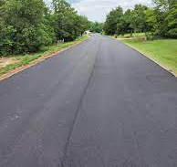
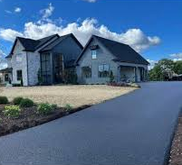
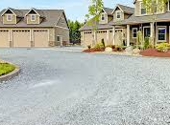
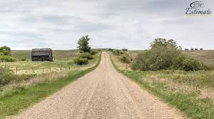
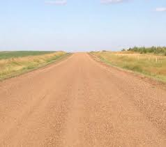
10 foot wide Driveway 12 foot wide one way Road 20 foot wide two lane Road

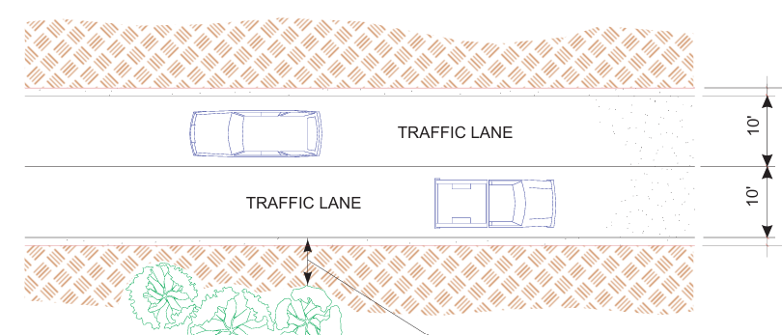
Two Lane Road

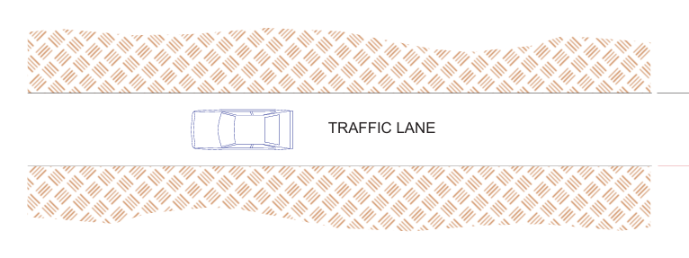
One Lane Road – 12 Foot Wide

Driveway – 10 Foot Wide



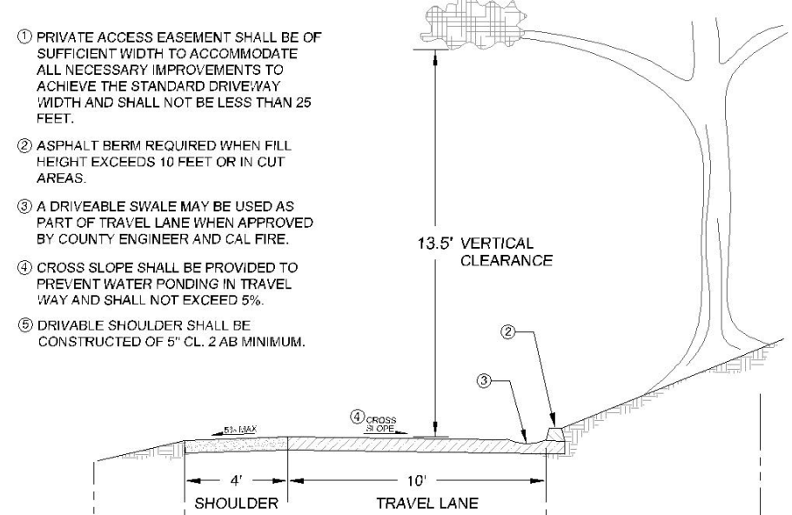
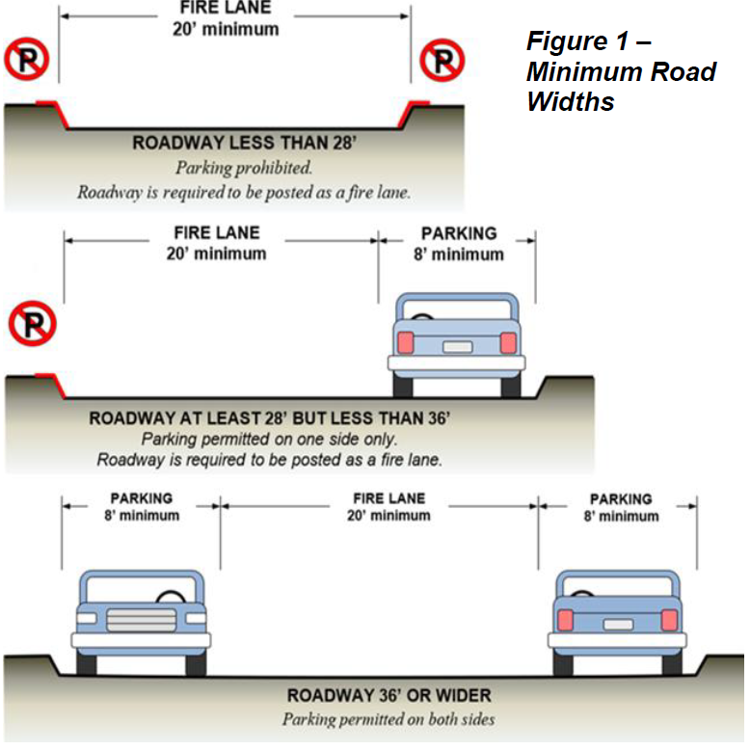

§ 1273.02. Road Surface
(a) Roads shall be designed and maintained to support the imposed load of Fire Apparatus weighing at least 75,000 pounds and provide an aggregate base.
(b) Road and Driveway Structures shall be designed and maintained to support at least 40,000 pounds.
Aggregrate(c) Project proponent shall provide engineering specifications to support design, if requested by the Local Jurisdiction.


Aggregate Road Example:
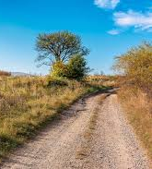

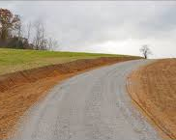

Aggregate Dirt, Prohibited Aggregate

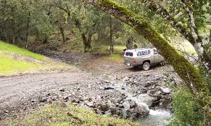
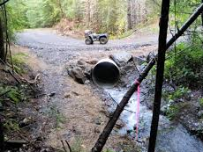
Driving through water, Prohibited Approved

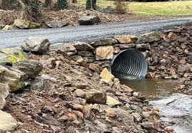
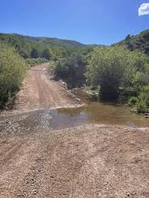
Driving through water, Prohibited Approved
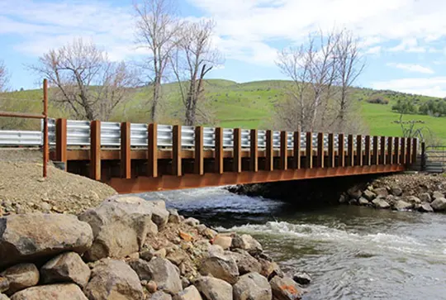
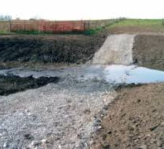
Driving through Water, Prohibited Approved

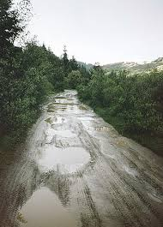
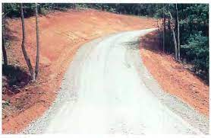

Driving in mud, Prohibited Approved

Gravel Road Example:

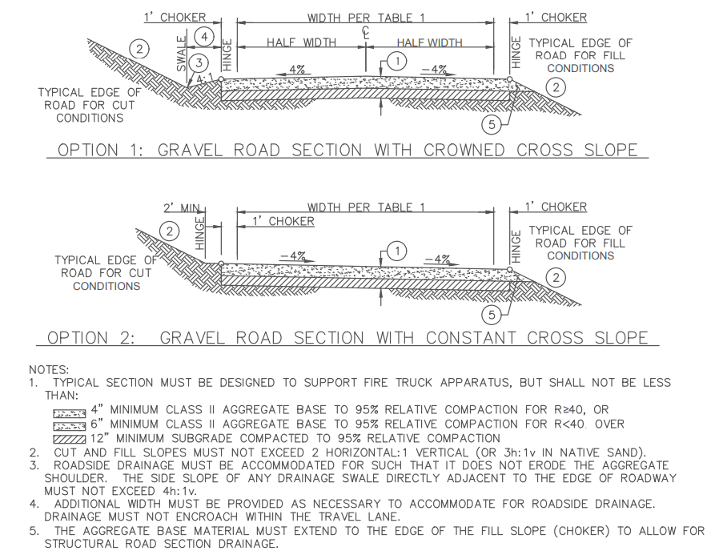

Paved Road Example:

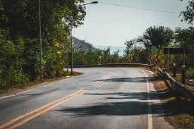
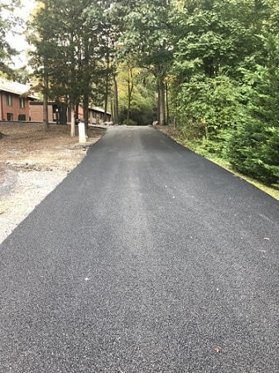

20 foot wide Two-Lane Road 10 foot wide Driveway

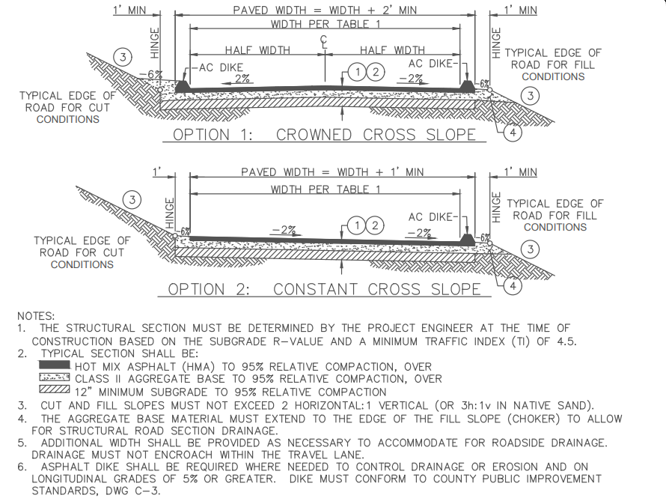

§ 1273.03. Grades
(a) At no point shall the grade for all Roads and Driveways exceed 16 percent.
(b) The grade may exceed 16%, not to exceed 20%, with approval from the Local Jurisdiction and with mitigations to provide for Same Practical Effect.
(The AHJ can approval other surfaces that meet the 1273.02 standard.)
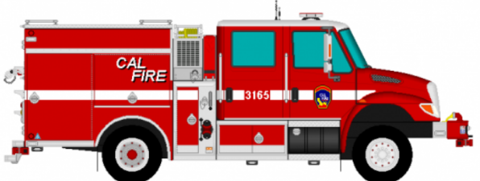
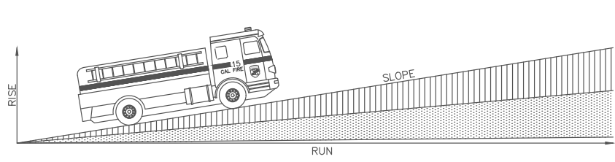

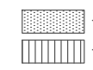
0-16%
16-20%

(16-20% “same practical effect” use of asphalt or concrete surface is industry standard)

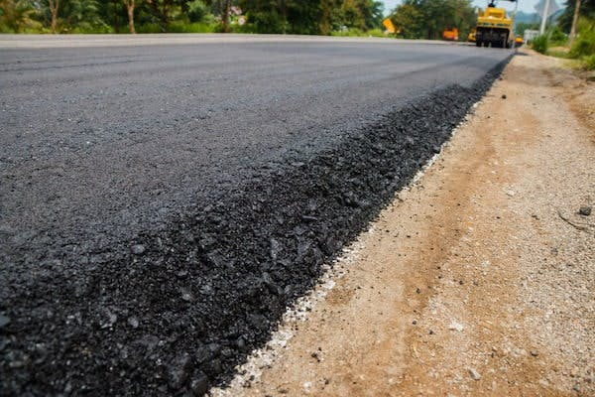
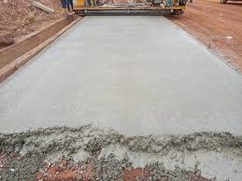
Concrete Surface Asphalt Surface

§ 1273.04. Radius
(a) No Road or Road Structure shall have a horizontal inside radius of curvature of less than fifty (50) feet. An additional surface width of four (4) feet shall be added to curves of 50-100 feet radius; two (2) feet to those from 100-200 feet.
(b) The length of vertical curves in Roadways, exclusive of gutters, ditches, and drainage structures designed to hold or divert water, shall be not less than one hundred (100) feet.
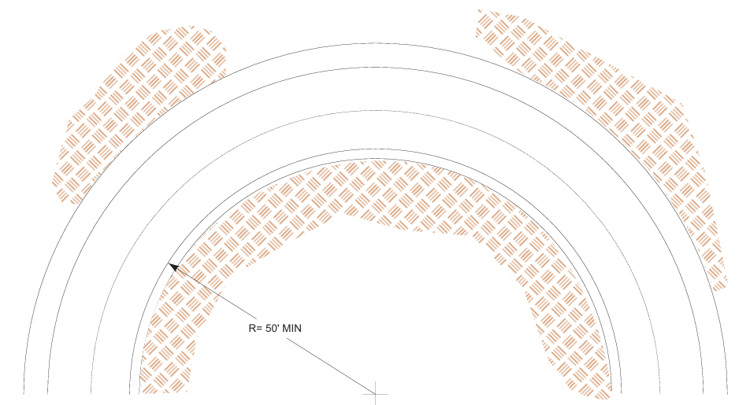
Special Consideration:
From the end or intersection of a County Maintained Road, to the permitted structure location, the access shall meet a Road Standard determined by the County process. There are three Road Standards: Driveway, One Way Road, Two Lane Road. County Maintained Roads information is available upon request from the AHJs Roads, or Public Works Department. Applicants should verify/check to see where the applicants Road Standard starts as part of their project with the Roads or Public Works Department.

§ 1273.05. Turnarounds
(a) Turnarounds are required on Driveways and Dead-end Roads.
(b) The minimum turning radius for a turnaround shall be forty (40) feet, not including parking, in accordance with the figures in 14 CCR §§ 1273.05(e) and 1273.05(f). If a hammerhead/T is used instead, the top of the “T” shall be a minimum of sixty (60) feet in length.
(c) Driveways exceeding 150 feet in length, but less than 800 feet in length, shall provide a turnout near the midpoint of the Driveway. Where the driveway exceeds 800 feet, turnouts shall be provided no more than 400 feet apart.
(d) A turnaround shall be provided on Driveways over 300 feet in length and shall be within fifty (50) feet of the building.
(d) Each Dead-end Road shall have a turnaround constructed at its terminus. Where parcels are zoned five (5) acres or larger, turnarounds shall be provided at a maximum of 1,320 foot intervals.
(e) Figure A. Turnarounds on roads with two ten-foot traffic lanes.
Figure A/Image 1 on the left is a visual representation of paragraph (b).
(f) Figure B. Turnarounds on driveways with one ten-foot traffic lane.
Figure B/Image 2 on the right is a visual representation of paragraph (b).

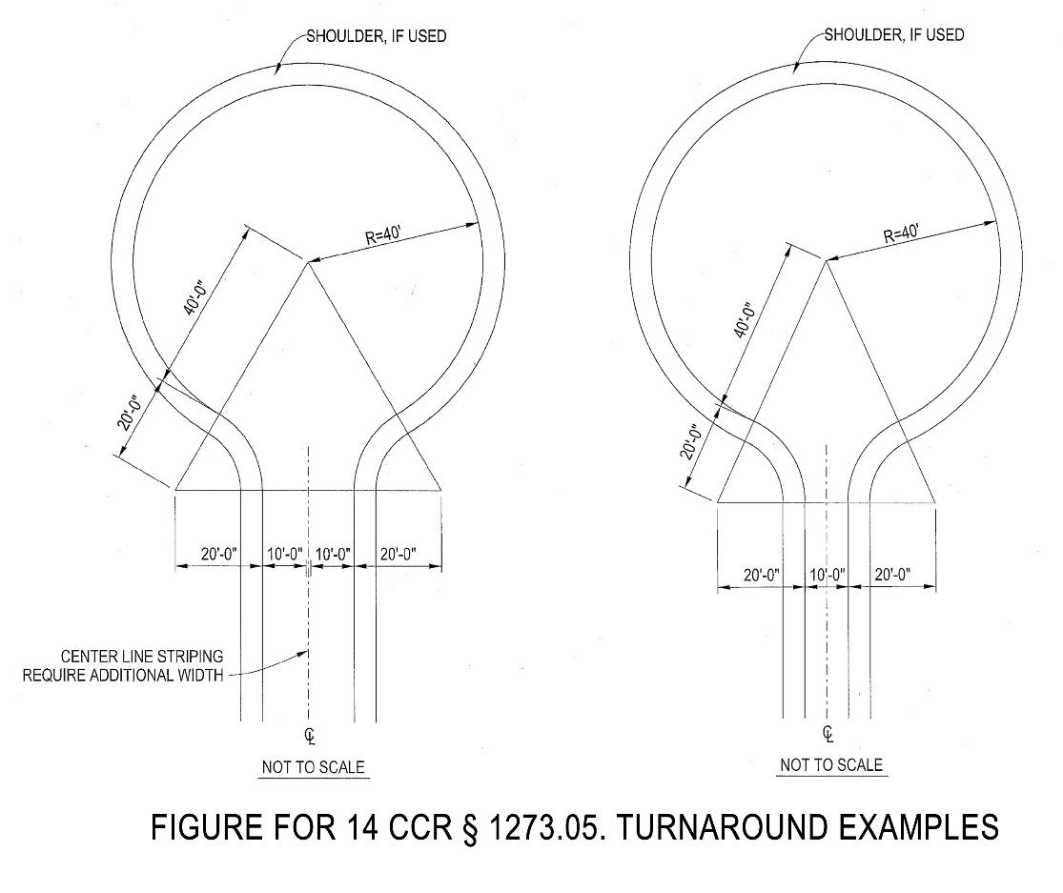

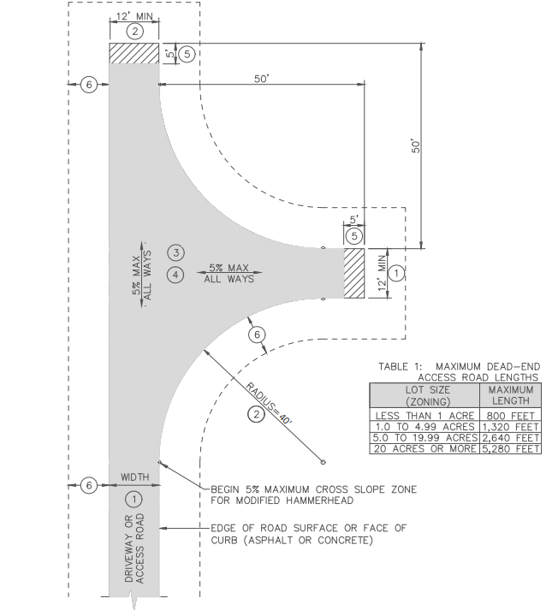

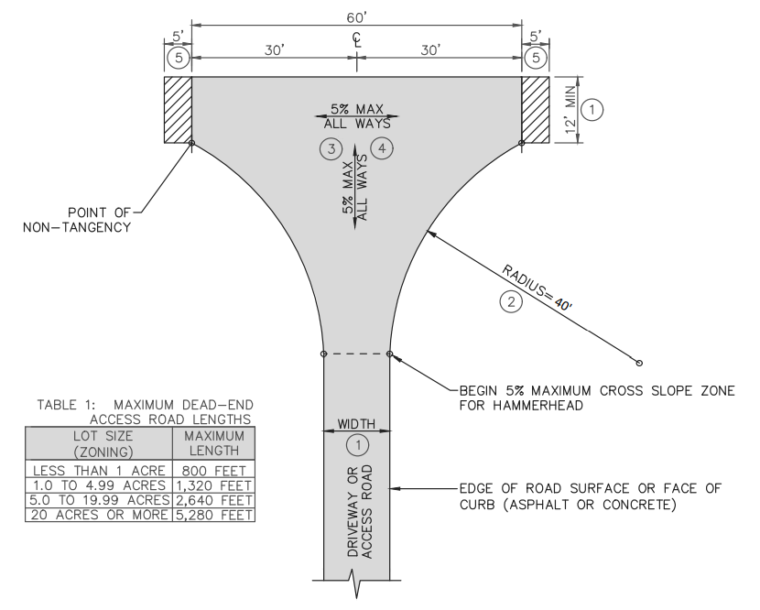

§ 1273.06. Turnouts
Turnouts shall be a minimum of twelve (12) feet wide and thirty (30) feet long with a minimum twenty-five (25) foot taper on each end.
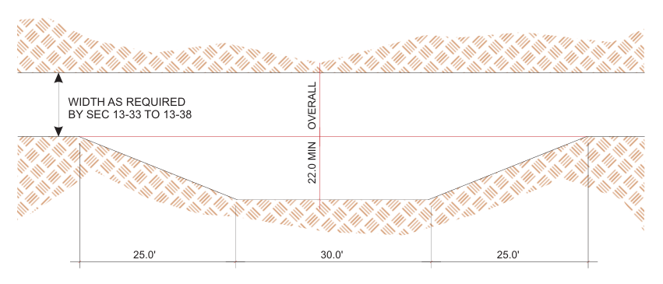

§ 1273.07. Road and Driveway Structures
(a) Appropriate signing, including but not limited to weight or vertical clearance limitations, One-way Road or single traffic lane conditions, shall reflect the capability of each bridge.
(b) Where a bridge or an elevated surface is part of a Fire Apparatus access road, the bridge shall be constructed and maintained in accordance with the American Association of State and Highway Transportation Officials Standard Specifications for Highway Bridges, 17th Edition, published 2002 (known as AASHTO HB-17), hereby incorporated by reference. Bridges and elevated surfaces shall be designed for a live load sufficient to carry the imposed loads of fire apparatus. Vehicle load limits shall be posted at both entrances to bridges when required by the local authority having jurisdiction.
(c) Where elevated surfaces designed for emergency vehicle use are adjacent to surfaces which are not designed for such use, barriers, or signs, or both, as approved by the local authority having jurisdiction, shall be installed and maintained.
(d) A bridge with only one traffic lane may be authorized by the Local Jurisdiction; however, it shall provide for unobstructed visibility from one end to the other and turnouts at both ends.

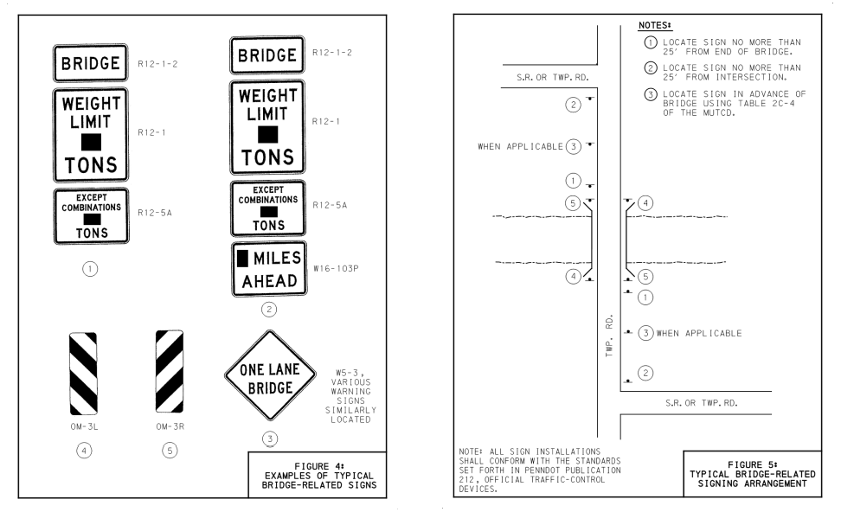

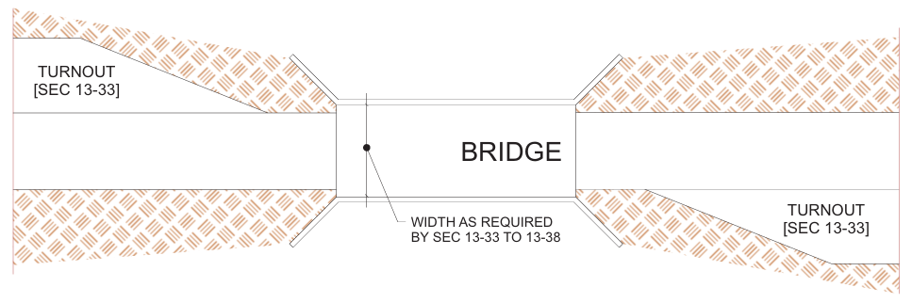
One Way Bridge – 12 Foot Wide – Turnouts on each side


Two Way Bridge – 20 Foot Wide – No turnouts needed
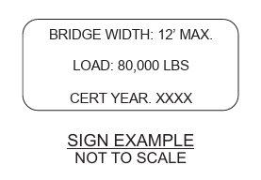

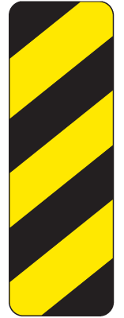
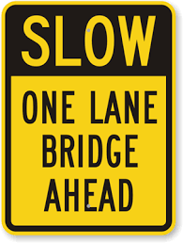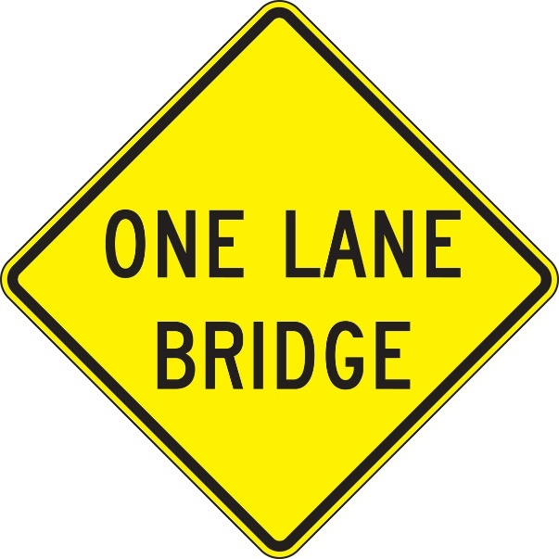

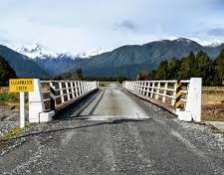
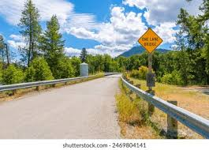

§ 1273.08. Dead-end Roads
(a) The maximum length of a Dead-end Road, including all Dead-end Roads accessed from that Dead-end Road, shall not exceed the following cumulative lengths, regardless of the number of parcels served:
parcels zoned for less than one acre - 800 feet
parcels zoned for 1 acre to 4.99 acres - 1,320 feet
parcels zoned for 5 acres to 19.99 acres - 2,640 feet
parcels zoned for 20 acres or larger - 5,280 feet
All lengths shall be measured from the edge of the Road surface at the intersection that begins the Road to the end of the Road surface at its farthest point. Where a dead-end road crosses areas of differing zoned parcel sizes requiring different length limits, the shortest allowable length shall apply.
(b) See 14 CCR § 1273.05 for dead-end road turnaround requirements.

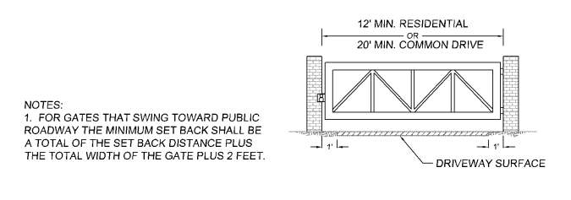

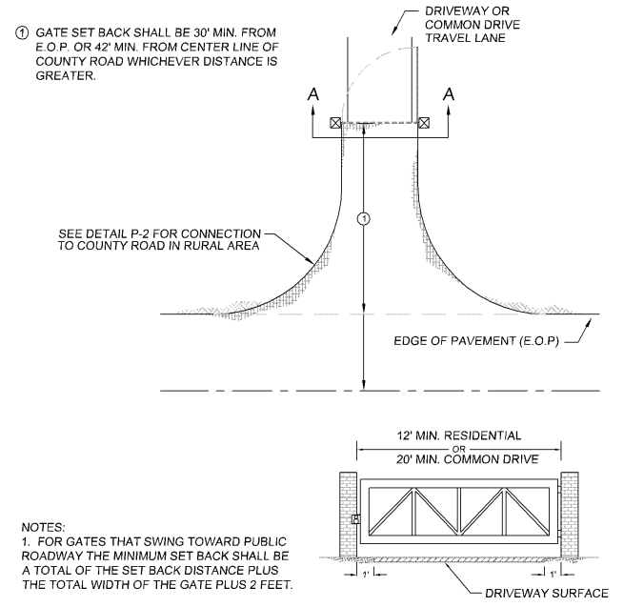

§ 1273.09. Gate Entrances
(a) Gate entrances shall be at least two (2) feet wider than the width of the traffic lane(s) serving that gate and a minimum width of fourteen (14) feet unobstructed horizontal clearance and unobstructed vertical clearance of thirteen feet, six inches (13′ 6″).
(b) All gates providing access from a Road to a Driveway shall be located at least thirty (30) feet from the roadway and shall open to allow a vehicle to stop without obstructing traffic on that Road.
(c) Where a One-way Road with a single traffic lane provides access to a gated entrance, a forty (40) foot turning radius shall be used.
(d) Security gates shall not be installed without approval. Where security gates are installed, they shall have an approved means of emergency operation. Approval shall be by the local authority having jurisdiction. The security gates and the emergency operation shall be maintained operational at all times
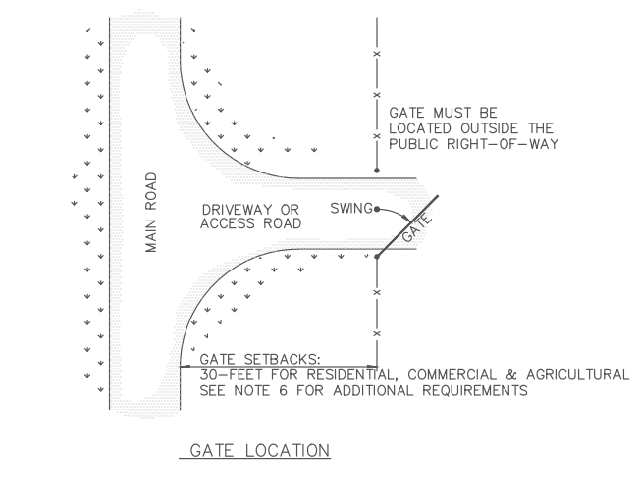

Driveway – 10 Foot Wide Road – Gate Minimum Width – 12 Foot Wide
One Lane Road – 12 Foot Wide Road – Gate Minimum Width – 14 Foot Wide
Two Lane Road – 20 Foot Wide Road – Gate Minimum Width – 22 Foot Wide
Fire Department Approved Key Access is a local option from the AHJ

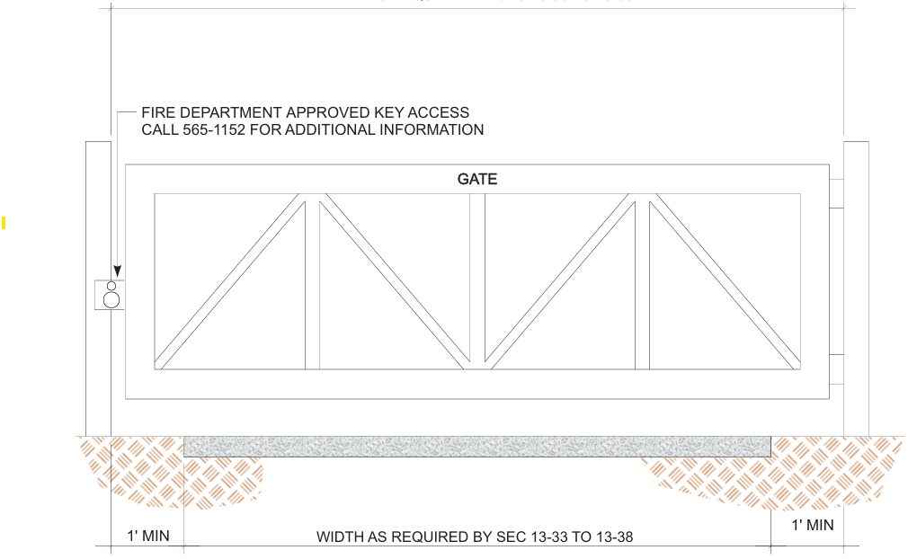

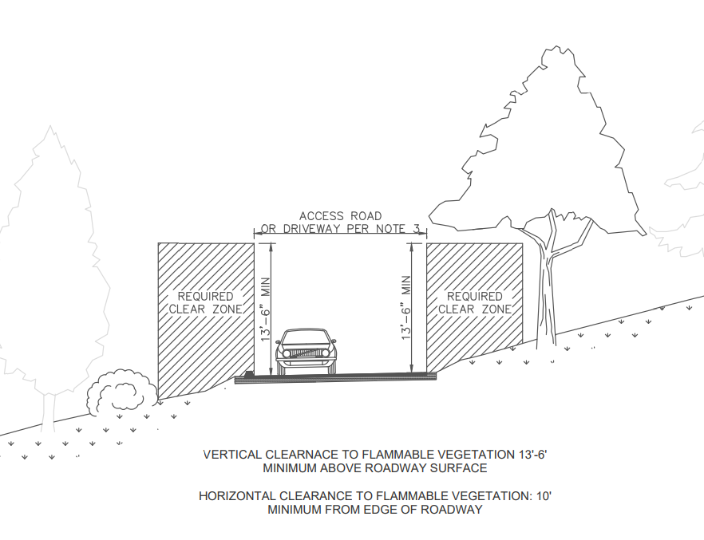

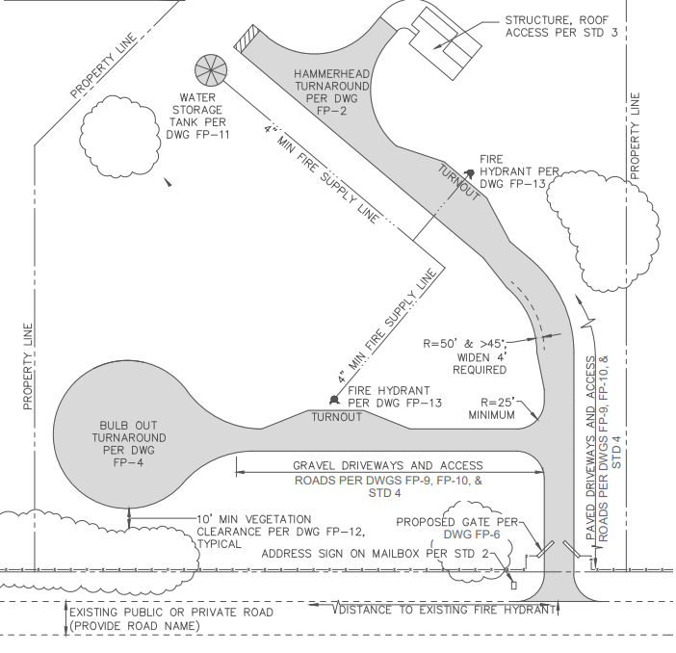

Site Plan Example

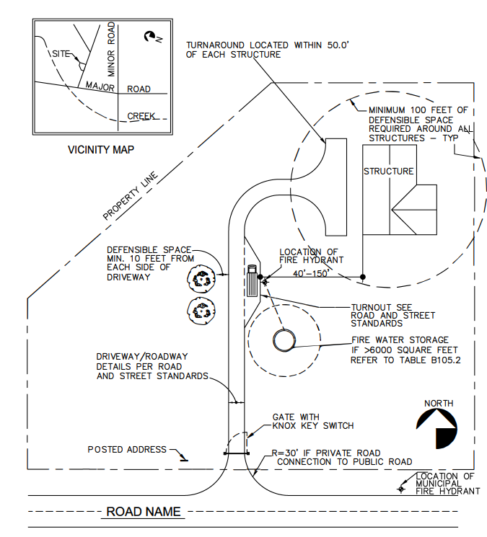

Site Plan Example

Article 3 Signing and Building Numbering

§ 1274.00. Intent
To facilitate locating a fire and to avoid delays in response, all newly constructed or approved Roads and Buildings shall be designated by names or numbers posted on signs clearly visible and legible from the Road. This section shall not restrict the size of letters or numbers appearing on road signs for other purposes.

§ 1274.01. Road Signs.
(a) Newly constructed or approved Roads must be identified by a name or number through a consistent system that provides for sequenced or patterned numbering and/or non-duplicative naming within each Local Jurisdiction. This section does not require any entity to rename or renumber existing roads, nor shall a Road providing access only to a single commercial or industrial Occupancy require naming or numbering.
(b) The size of letters, numbers, and symbols for Road signs shall be a minimum four (4) inch letter height, half inch (.5) inch stroke, reflectorized, contrasting with the background color of the sign.

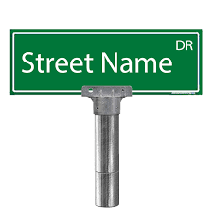

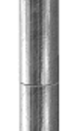
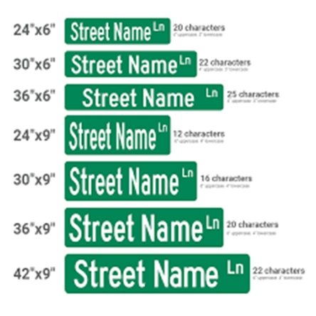

Street Sign Example
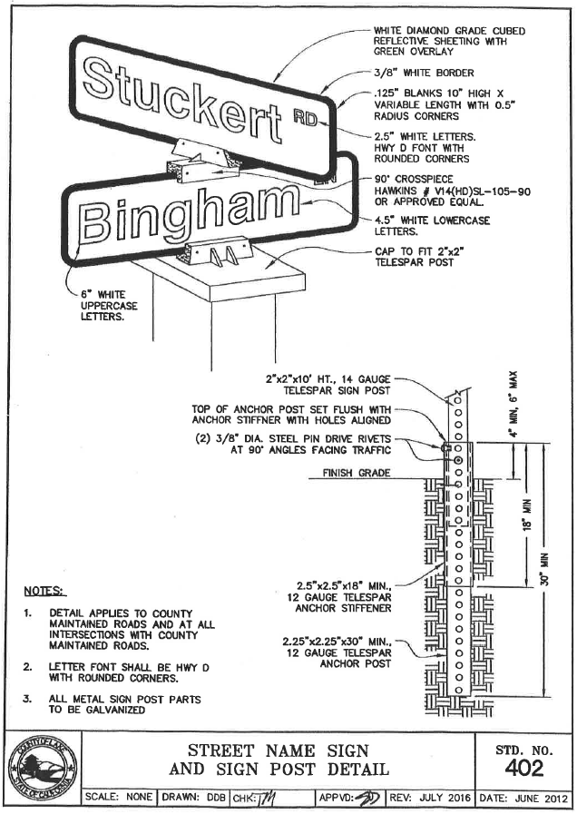

Street Sign Example
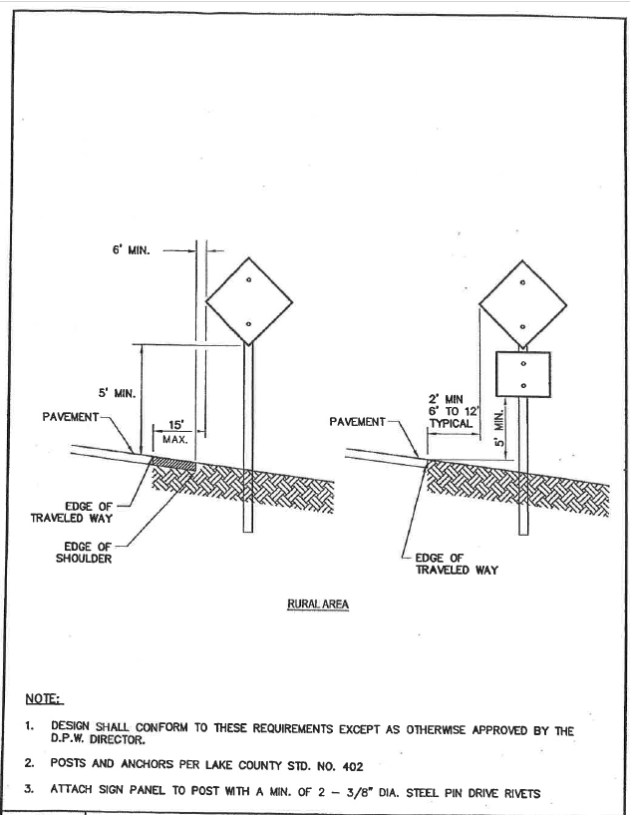

Road Sign Example
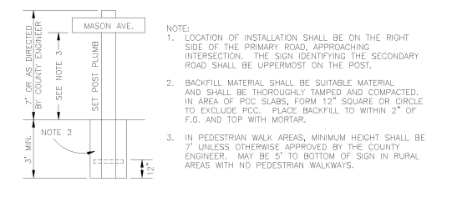

Street Sign Example

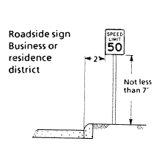
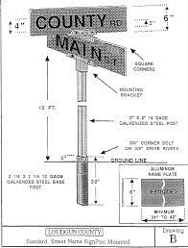

Street and Road Sign Examples
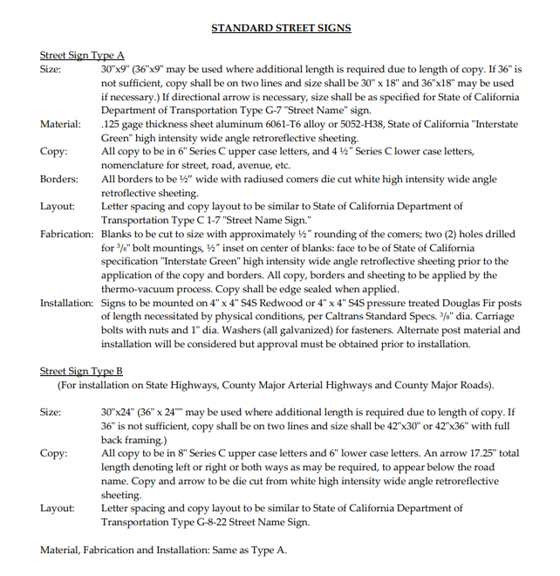

§ 1274.02. Road Sign Installation, Location, and Visibility.
(a) Road signs shall be visible and legible from both directions of vehicle travel for a distance of at least one hundred (100) feet.
(b) Signs required by this article identifying intersecting Roads shall be placed at the intersection of those Roads.
(c) A sign identifying traffic access or flow limitations, including but not limited to weight or vertical clearance limitations, dead-end roads, one-way roads, or single lane conditions, shall be placed:
(1) at the intersection preceding the traffic access limitation, and
(2) no more than one hundred (100) feet before such traffic access limitation.
(d) Road signs required by this article shall be posted at the beginning of construction and shall be maintained thereafter.
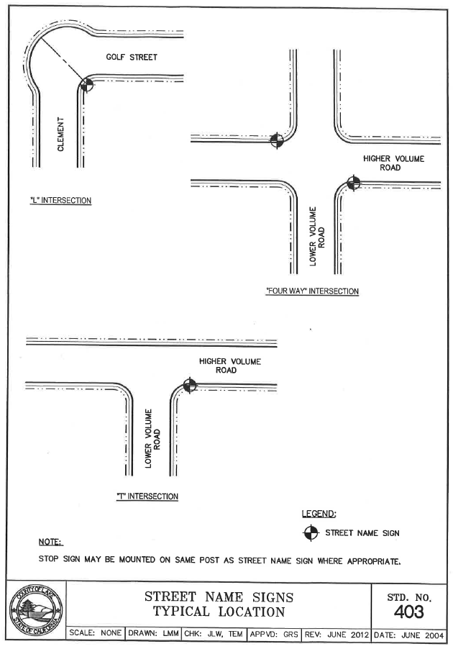

Street and Road Sign Location Example

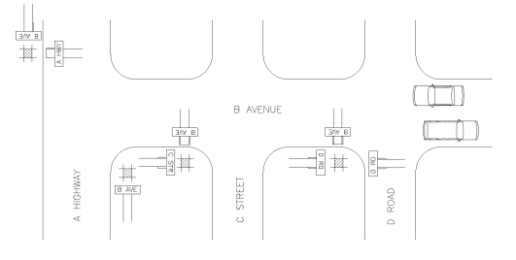

Street and Road Sign Location Example

§ 1274.03. Addresses for Buildings.
(a) All Buildings shall be issued an address by the Local Jurisdiction which conforms to that jurisdiction's overall address system. Utility and miscellaneous Group U Buildings are not required to have a separate address; however, each Residential Unit within a Building shall be separately identified.
(b) The size of letters, numbers, and symbols for addresses shall conform to the standards in the California Fire Code, California Code of Regulations title 24, part 9.
(c) Addresses for residential Buildings shall be reflectorized.

§ 1274.04. Address Installation, Location, and Visibility.
(a) All buildings shall have a permanently posted address which shall be plainly legible and visible from the Road fronting the property.
(b) Where access is by means of a private Road and the address identification cannot be viewed from the public way, an unobstructed sign or other means shall be used so that the address is visible from the public way.
(c) Address signs along one-way Roads shall be visible from both directions.
(d) Where multiple addresses are required at a single driveway, they shall be mounted on a single sign or post.
(e) Where a Road provides access solely to a single commercial or industrial business, the address sign shall be placed at the nearest Road intersection providing access to that site or otherwise posted to provide for unobstructed visibility from that intersection.
(f) In all cases, the address shall be posted at the beginning of construction and shall be maintained thereafter.

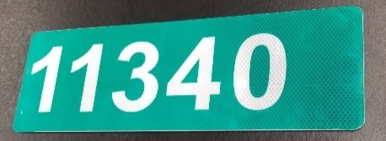
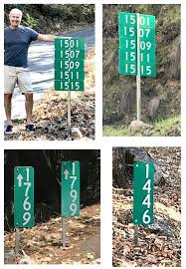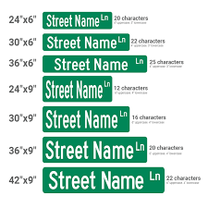
Address Sign Example
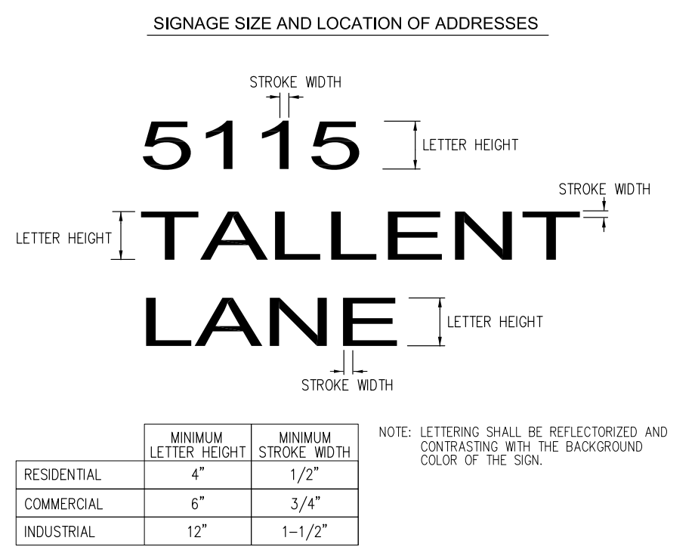

Article 4 Emergency Water Standards

§ 1275.00. Intent
Emergency water for Wildfire protection shall be available, accessible, and maintained in quantities and locations specified in the statute and these regulations in order to attack a Wildfire or defend property from a Wildfire.

§ 1275.01. Application
The provisions of this article shall apply in the tentative and parcel map process when new parcels are approved by the Local Jurisdiction.

§ 1275.02. Water Supply.
(a) When a water supply for structure defense is required to be installed, such protection shall be installed and made serviceable prior to and during the time of construction except when alternative methods of protection are provided and approved by the Local Jurisdiction.
(b) Water systems equaling or exceeding the California Fire Code, California Code of Regulations title 24, part 9, or, where a municipal-type water supply is unavailable, National Fire Protection Association (NFPA) 1142, “Standard on Water Supplies for Suburban and Rural Fire Fighting,” 2017 Edition, hereby incorporated by reference, shall be accepted as meeting the requirements of this article.
(c) Such emergency water may be provided in a fire agency mobile water tender, or naturally occurring or manmade containment structure, as long as the specified quantity is immediately available.
(d) Nothing in this article prohibits the combined storage of emergency Wildfire and structural firefighting water supplies unless so prohibited by local ordinance or specified by the local fire agency.
(e) Where freeze or crash protection is required by Local Jurisdictions, such protection measures shall be provided.

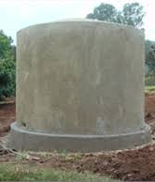
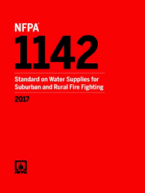
NFPA 1142 Concrete Water Tank

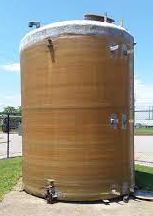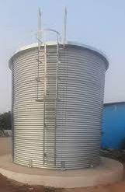
Fiberglass Water Tank Steel Water Tank

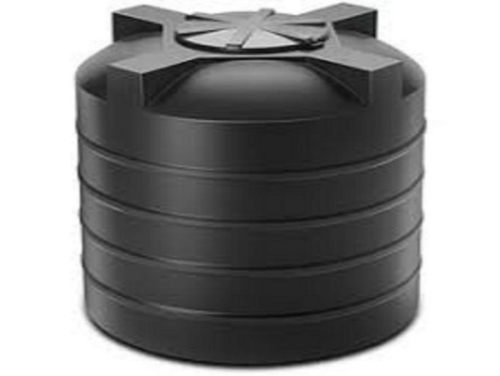
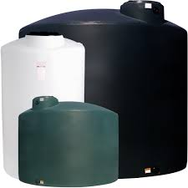

Plastic Water Tanks, not allowed Fiberglass reinforced plastic
per NFPA 1142

Special Consideration:
For decades plastic water tanks have been approved by multiple AHJs in Sonoma County for the storage of Fire Water. Title 14 Section, 1275.02 no longer allows plastic water tanks to be used for Fire Water Supply since it references NFPA 1142 for water storage that then references NFPA 42 for storage.
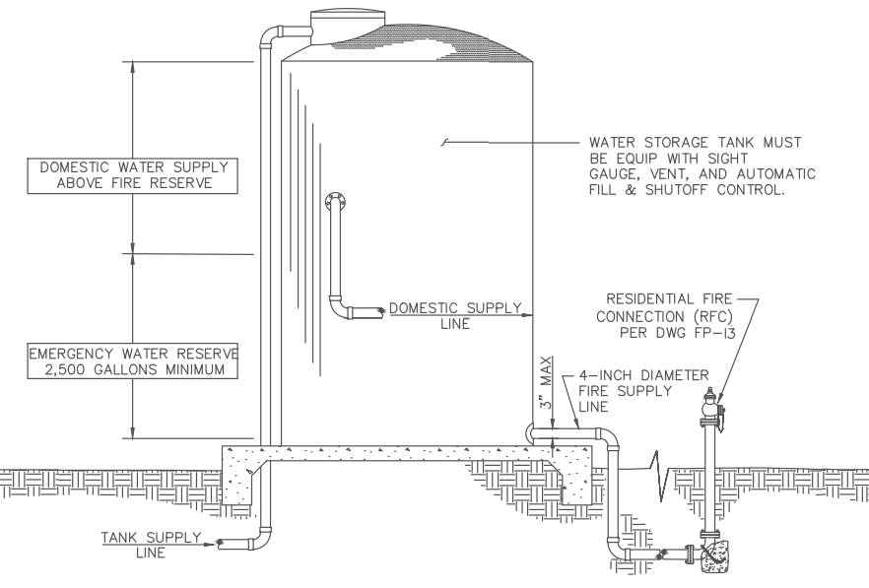
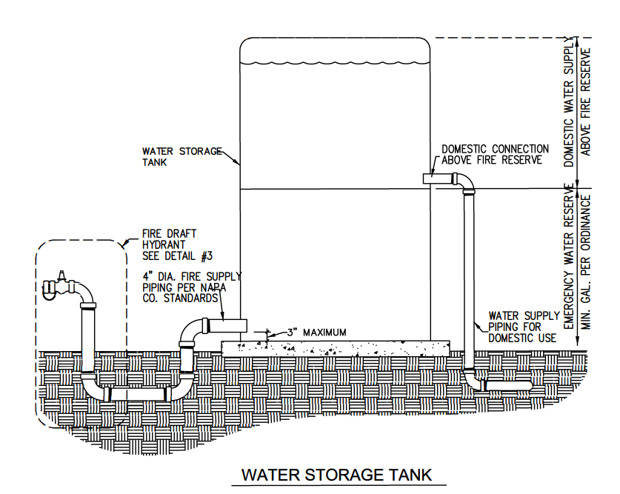

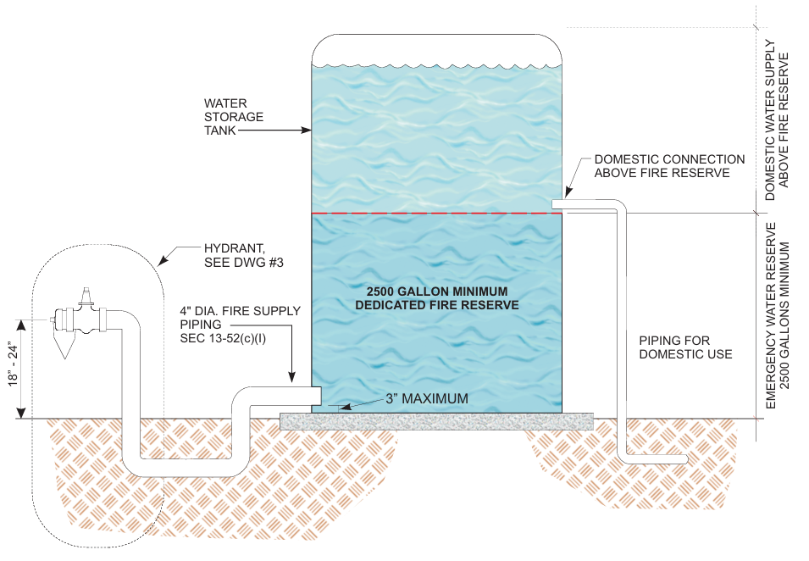

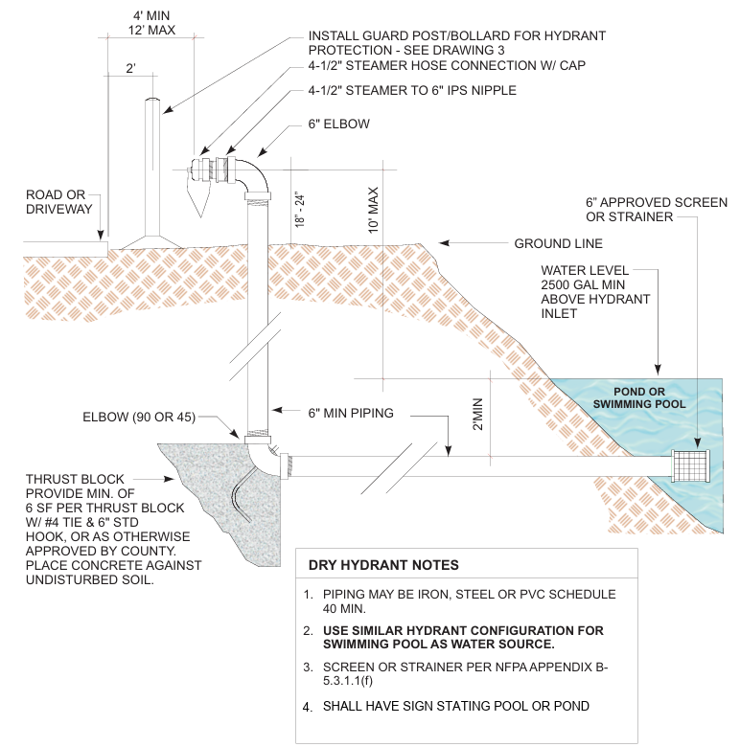

§ 1275.03. Hydrants and Fire Valves.
(a) The hydrant or fire valve shall be eighteen (18) inches above the finished surface. Its location in relation to the road or driveway and to the building(s) or structure(s) it serves shall comply with California Fire Code, California Code of Regulations title 24, part 9, Chapter 5, and Appendix C.
(b) The hydrant head shall be a two and half (2 1/2) inch National Hose male thread with cap for pressure and gravity flow systems and four and a half (4 1/2) inch for draft systems.
(c) Hydrants shall be wet or dry barrel and have suitable freeze or crash protection as required by the local jurisdiction.
§ 1275.04. Signing of Water Sources.
(a) Each hydrant, fire valve, or access to water shall be identified as follows:
(1) if located along a driveway, a reflectorized blue marker, with a minimum dimension of three (3) inches shall be located on the driveway address sign and mounted on a fire-retardant post, or
(2) if located along a road,
(i) a reflectorized blue marker, with a minimum dimension of three (3) inches, shall be mounted on a fire-retardant post. The signpost shall be within three (3) feet of said hydrant or fire valve, with the sign no less than three (3) feet nor greater than five (5) feet above ground, in a horizontal position and visible from the driveway, or
(ii) as specified in the State Fire Marshal's Guidelines for Fire Hydrant
Markings Along State Highways and Freeways, May 1988.

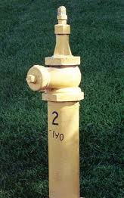
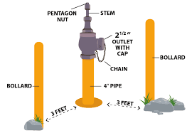

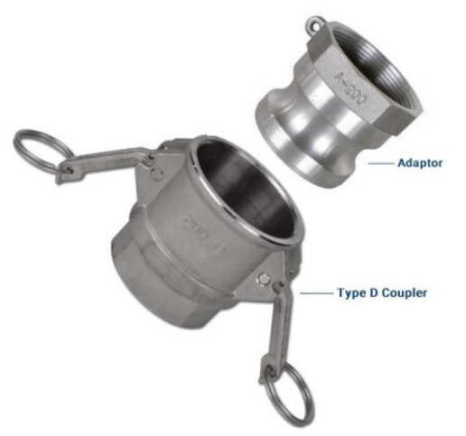
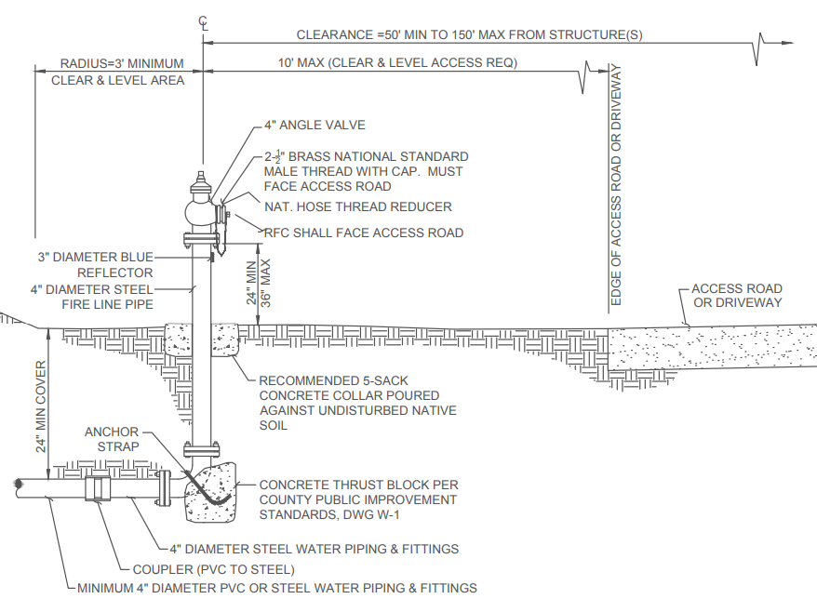

CAM-LOCK Fittings Not Allowed

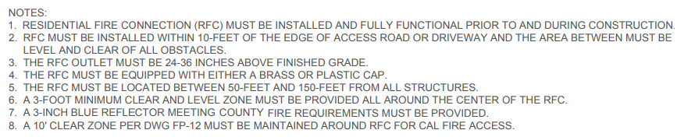
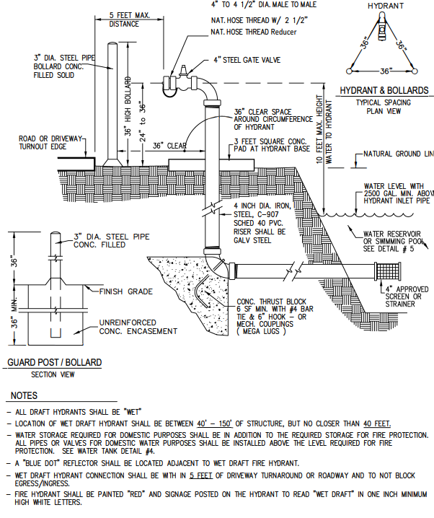
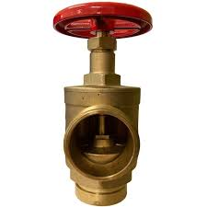
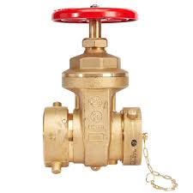

CAM-LOCK Fittings Not Allowed – Fittings shall be 2-1/2 inch National Male Threads

§ 1275.04. Signing of Water Sources.
(a) Each Fire Hydrant or access to water shall be identified as follows:
(1) if located along a Driveway, a reflectorized blue marker, with a minimum dimension of three (3) inches shall be located on the Driveway address sign and mounted on a fire retardant post, or
(2) if located along a Road,
(i) a reflectorized blue marker, with a minimum dimension of three (3) inches, shall be mounted on a fire retardant post. The sign post shall be within three (3) feet of said Fire Hydrant with the sign no less than three (3) feet nor greater than five (5) feet above ground, in a horizontal position and visible from the Driveway, or
(ii) as specified in the State Fire Marshal's Guidelines for Fire Hydrant Markings Along State Highways and Freeways, May 1988.
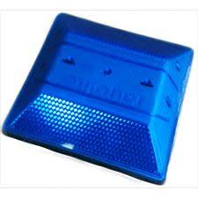


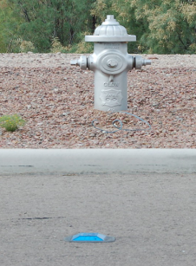

Article 5 Building Siting, Setbacks, and Fuel Modification

§ 1276.00 Intent
To reduce the intensity of a Wildfire, reducing the volume and density of flammable vegetation around Development through strategic fuel modification, parcel siting and Building setbacks, and the protection of Undeveloped Ridgelines shall provide for increased safety for emergency fire equipment, including evacuating civilians, and a point of attack or defense from a Wildfire.

§ 1276.01. Building and Parcel Siting and Setbacks
(a) All parcels shall provide a minimum thirty (30) foot setback for all Buildings from all property lines and/or the center of a Road, except as provided for in subsection (b).
(b) A reduction in the minimum setback shall be based upon practical reasons, which may include but are not limited to, parcel dimensions or size, topographic limitations, Development density requirements or other Development patterns that promote low-carbon emission outcomes; sensitive habitat; or other site constraints , and shall provide for an alternative method to reduce Structure-to-Structure ignition by incorporating features such as, but not limited to:
(1) non-combustible block walls or fences; or
(2) non-combustible material extending five (5) feet horizontally from the furthest extent of the Building; or
(3) hardscape landscaping; or
(4) a reduction of exposed windows on the side of the Structure with a less than thirty (30) foot setback; or
(5) the most protective requirements in the California Building Code, California Code of Regulations Title 24, Part 2, Chapter 7A, as required by the Local Jurisdiction.

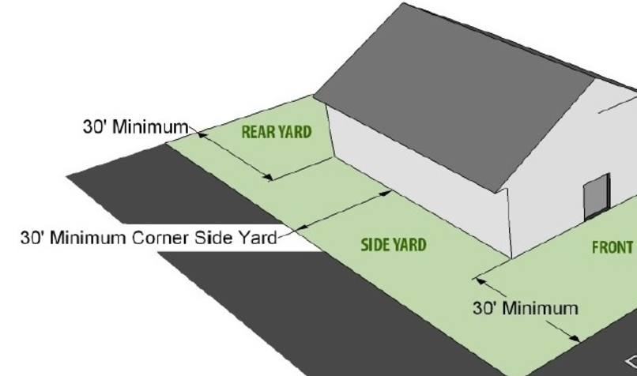

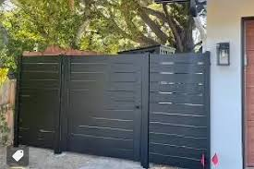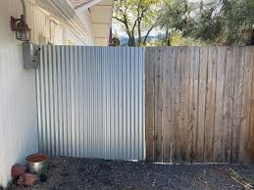

Zone 0 – Non-Combustible Fence to Structure Examples

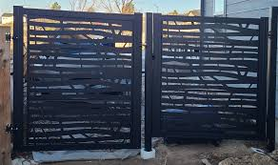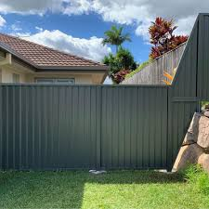

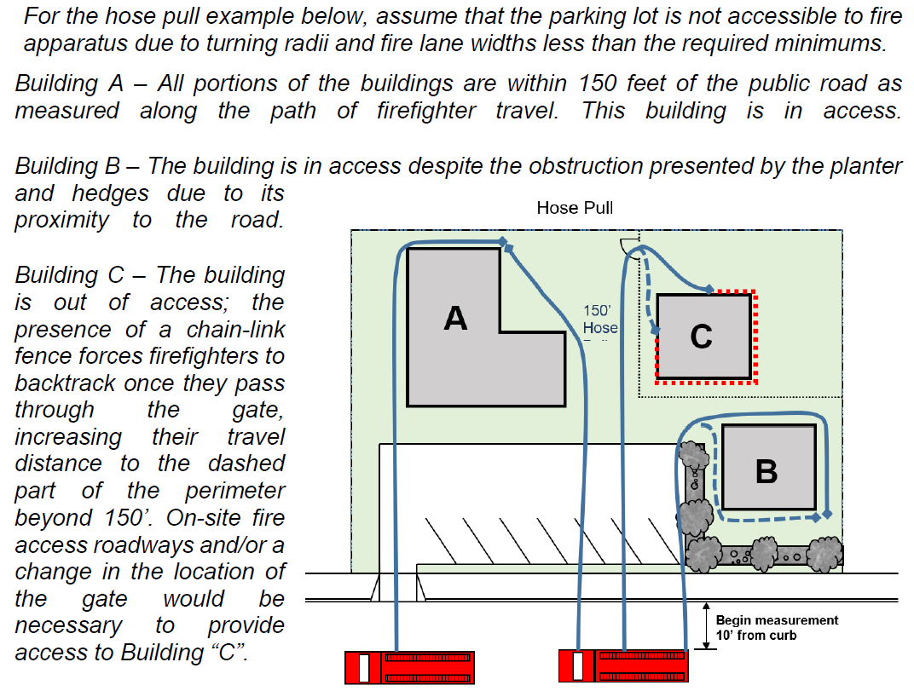

Structure Distance Examples – Not in Public Resource Code – Best Practices

Structure Distance Examples – Not in Public Resource Code – Best Practices
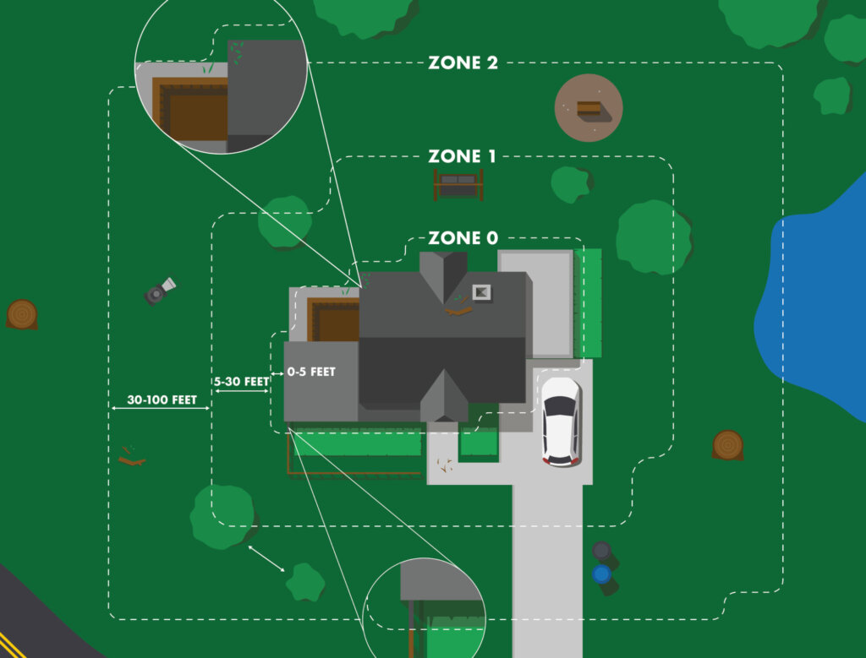

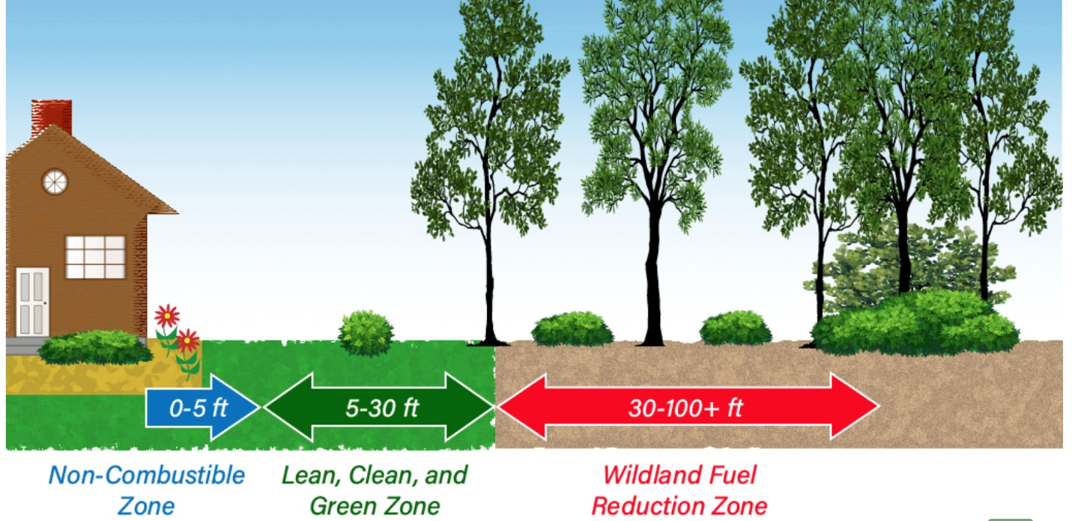

Zone 0 Zone 1 Zone 2

Zone 0 extends 5 feet from buildings, structures, decks, etc.
While not legally required yet, Zone 0 is key for wildfire defense and preventing fires from spreading to your home. Here are the current guidelines:
- Use gravel, pavers, or concrete instead of combustible mulch
- Clear dead weeds, grass, and debris; check roofs, gutters, and outdoor areas
- Keep branches trimmed 10 feet away from chimneys and stovepipes
- Minimize combustible items like furniture and planters on decks
- Move firewood and lumber to Zone 2 for safety
- Replace combustible fencing and gates with fire-resistant materials
- Shift garbage and recycling containers to a safer area outside this zone
- Relocate boats, RVs, and vehicles away from this zone to reduce fire risks

Zone 1 extends 30 feet from buildings, structures, decks, etc. or to your property line, whichever is closer.
- Clear all dead plants, grass, and weeds
- Remove dead leaves and pine needles from your yard, roof, and gutters
- Trim overhanging branches and keep them 10 feet from your chimney
- Regularly trim trees to maintain a 10-foot gap from others
- Move wood piles to Zone 2
- Prune flammable plants and shrubs near windows
- Clear flammable vegetation and items from under decks, balconies, and stairs
- Maintain space between trees, shrubs, and flammable items like patio furniture and wood piles
- Ensure outbuildings and LPG tanks have 10 feet of clear space to bare soil and no flammable vegetation within an additional 10 feet around them

Zone 2 extends from 30 feet to 100 feet out from buildings, structures, decks, etc. or to your property line, whichever is closer.
- Trim annual grass to a maximum height of 4 inches
- Space out shrubs and trees horizontally (See diagram)
- Ensure vertical spacing between grass, shrubs, and trees (See diagram)
- Remove fallen leaves, needles, and small branches, but can leave up to 3 inches
- Keep exposed wood piles at least 10 feet clear from surroundings, down to the soil
- Ensure outbuildings and LPG tanks have 10 feet of clear space to bare soil and no flammable vegetation within an additional 10 feet around them

Vegetation Spacing:

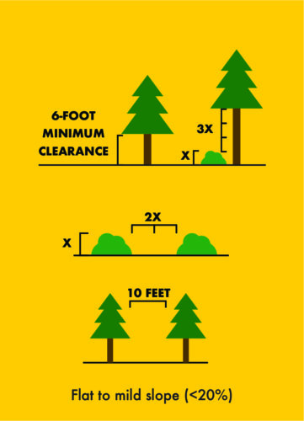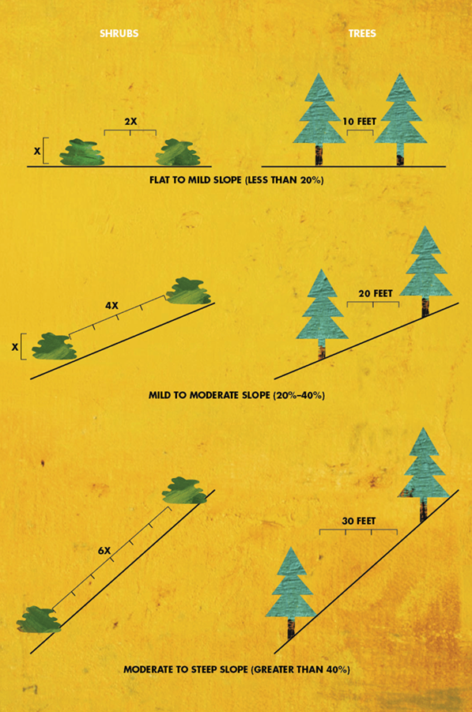

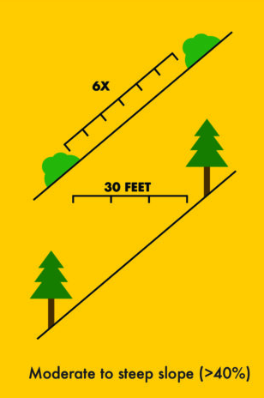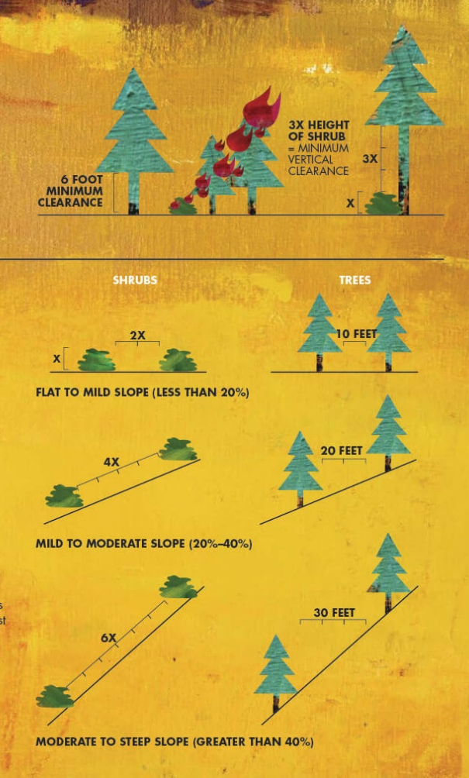

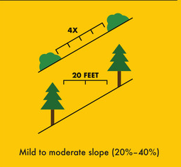
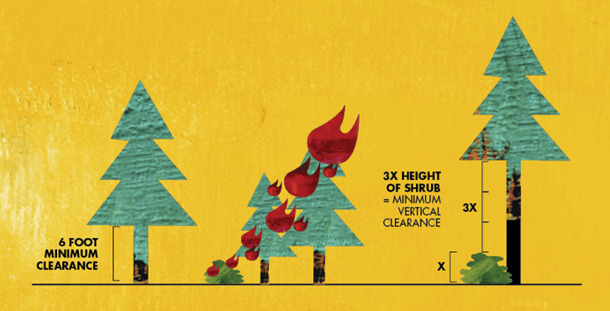

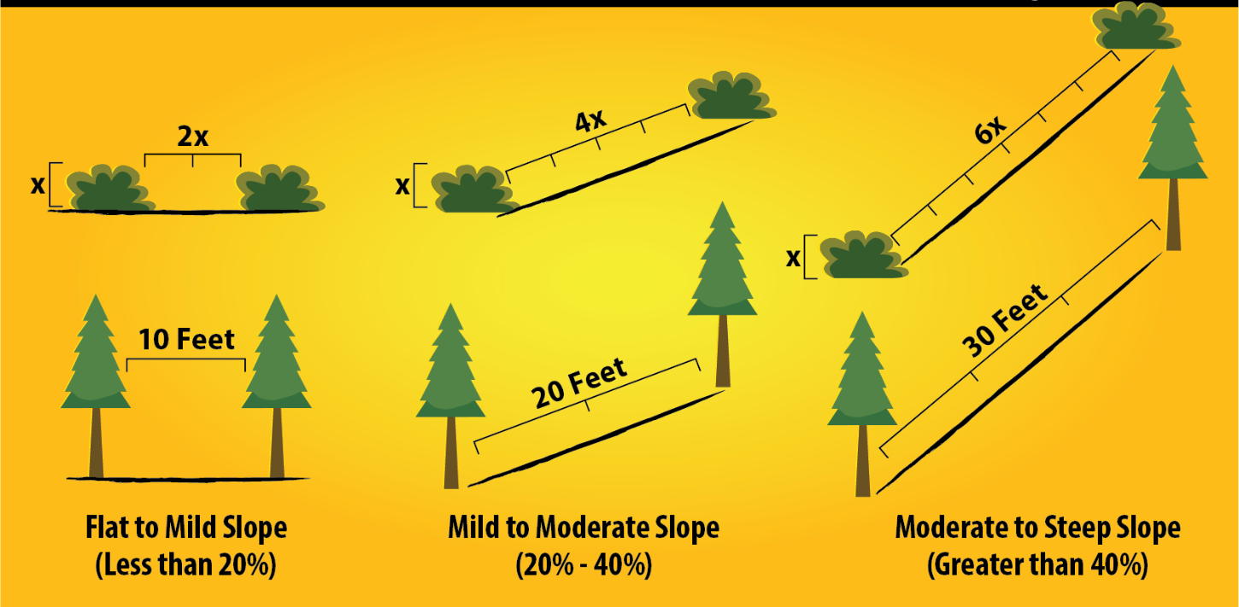

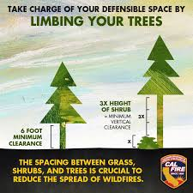
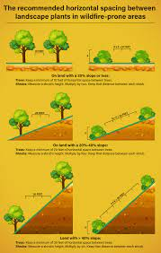

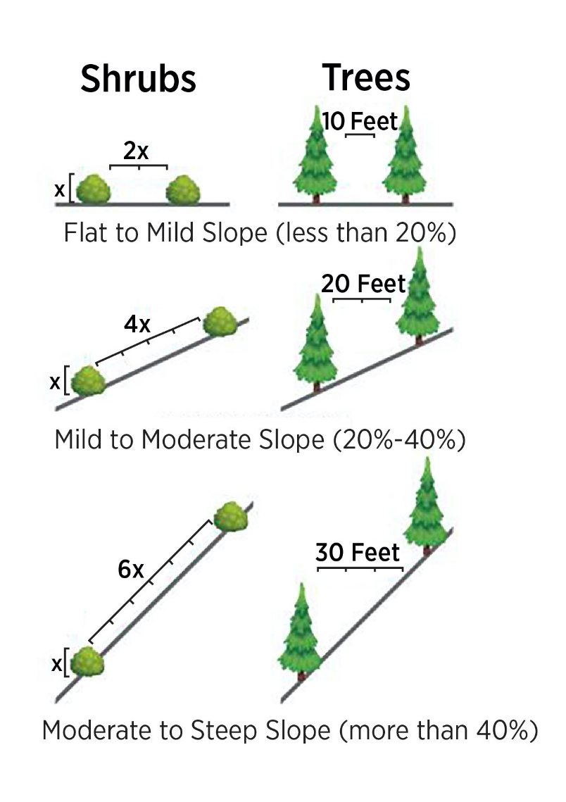
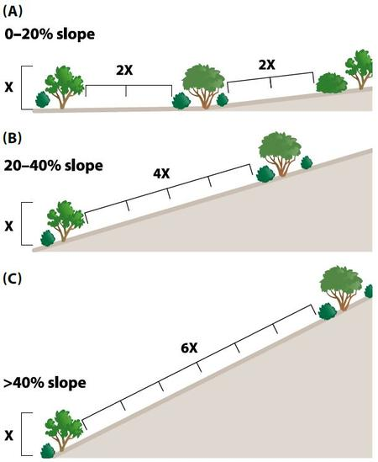

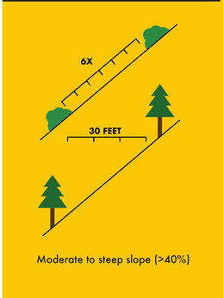
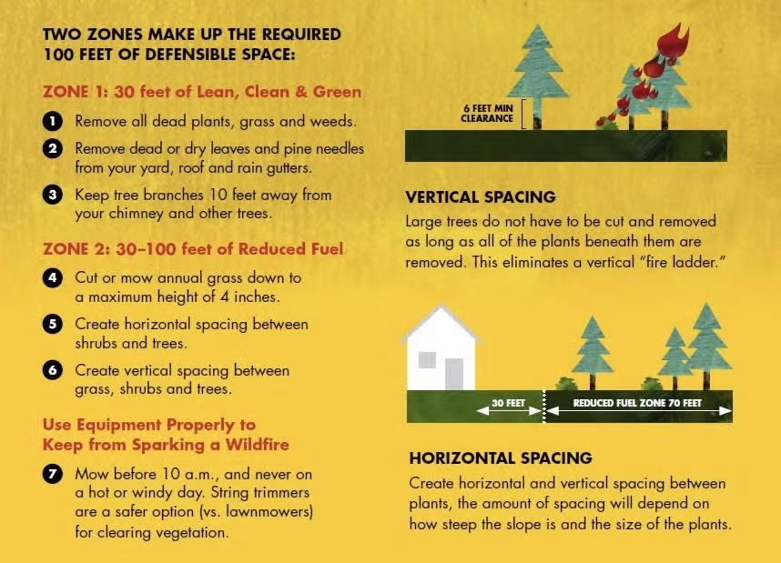
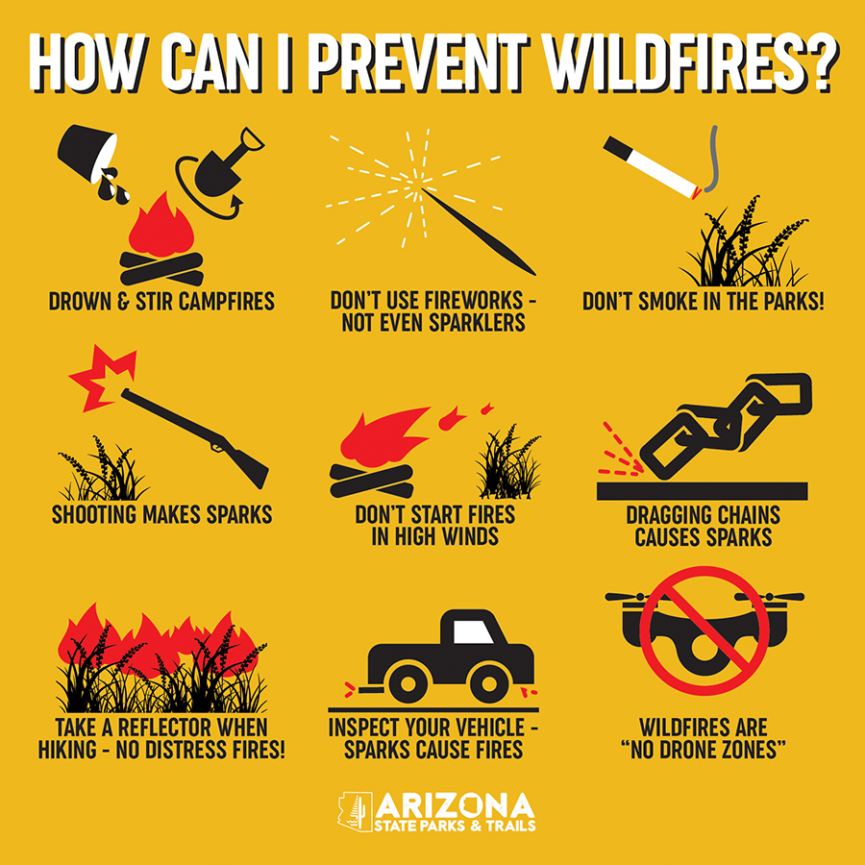

§ 1276.02. Ridgelines
(a) The Local Jurisdiction shall identify Strategic Ridgelines, if any, to reduce fire risk and improve fire protection through an assessment of the following factors:
(1) Topography.
(2) Vegetation.
(3) Proximity to any existing or proposed residential, commercial, or industrial land uses.
(4) Construction where mass grading may significantly alter the topography resulting in the elimination of Ridgeline fire risks.
(5) Ability to support effective fire suppression; and
(6) Other factors, if any, deemed relevant by the Local Jurisdiction.
(b) Preservation of Undeveloped Ridgelines identified as strategically important shall be required pursuant to this section.
(c) New Buildings on Undeveloped Ridgelines identified as strategically important are prohibited, as described in subsections (c)(1), (c)(2), and (c)(3).
(1) New Residential Units are prohibited within or at the top of drainages or other topographic features common to Ridgelines that act as chimneys to funnel convective heat from Wildfires.
(2) Nothing in this subsection shall be construed to alter the extent to which utility infrastructure, including but not limited to wireless telecommunications facilities, as defined in Government Code section 65850.6, subdivision (d)(2), or Storage Group S or Utility and Miscellaneous Group U Structures, may be constructed on Undeveloped Ridgelines.
(3) Local Jurisdictions may approve Buildings on Strategic Ridgelines where Development activities such as mass grading will significantly alter the topography that results in the elimination of Ridgeline fire risks.
(d) The Local Jurisdiction may implement further specific requirements to preserve Undeveloped Ridgelines.
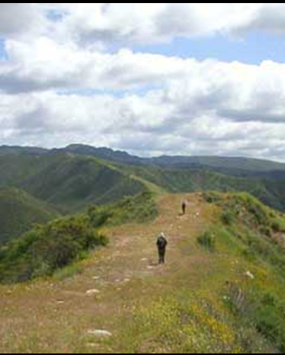
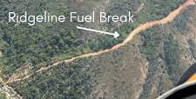

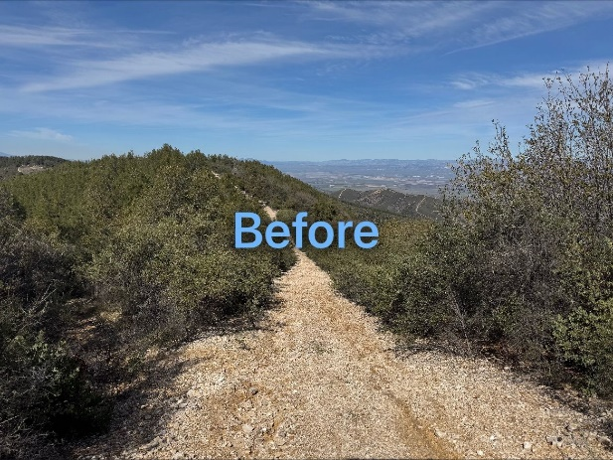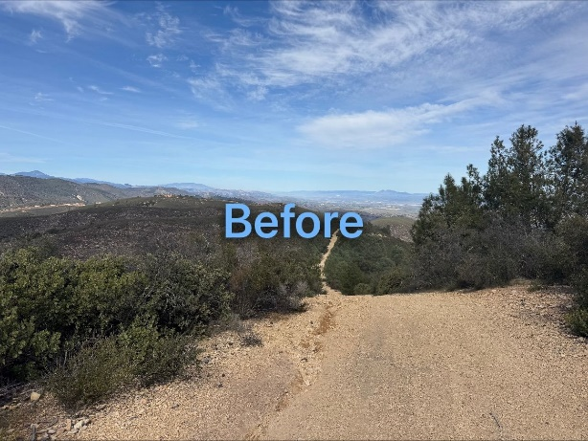

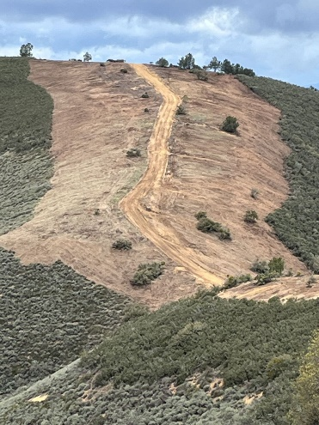
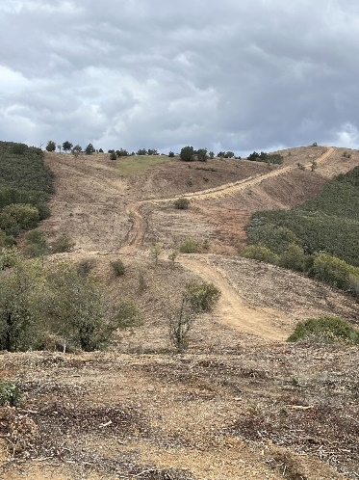

After
After

§ 1276.03. Fuel Breaks
(a) When Building construction meets the following criteria, the Local Jurisdiction shall determine the need and location for Fuel Breaks in consultation with the Fire Authority:
(1) the permitting or approval of three (3) or more new parcels, excluding lot line adjustments as specified in Government Code (GC) section 66412(d); or
(2) an application for a change of zoning increasing zoning intensity or density; or
(3) an application for a change in use permit increasing use intensity or density.
(b) Fuel Breaks required by the Local Jurisdiction, in consultation with the Fire Authority, shall be located, designed, and maintained in a condition that reduces the potential of damaging radiant and convective heat or ember exposure to Access routes, Buildings, or infrastructure within the Development.
(c) Fuel Breaks shall have at a minimum, one point of entry for fire fighters and any Fire Apparatus. The specific number of entry points and entry requirements shall be determined by the Local Jurisdiction, in consultation with the Fire Authority.
(d) Fuel Breaks may be required at locations such as, but not limited to:
(1) Directly adjacent to defensible space as defined by 14 CCR § 1299.02 to reduce radiant and convective heat exposure, ember impacts, or support fire suppression tactics.
(2) Directly adjacent to Roads to manage radiant and convective heat exposure or ember impacts, increase evacuation safety, or support fire suppression tactics.
(3) Directly adjacent to a Hazardous Land Use to limit the spread of fire from such uses, reduce radiant and convective heat exposure, or support fire suppression tactics.
(4) Strategically located along Ridgelines, in Greenbelts, or other locations to reduce radiant and convective heat exposure, ember impacts, or support community level fire suppression tactics.
(e) Fuel Breaks shall be completed prior to the commencement of any permitted construction.
(f) Fuel Breaks shall be constructed using the most ecologically and site appropriate treatment option, such as, but not limited to, prescribed burning, manual treatment, mechanical treatment, prescribed herbivory, and targeted ground application of herbicides.
(g) Where a Local Jurisdiction requires Fuel Breaks, maintenance mechanisms should be established to ensure the fire behavior objectives and thresholds are maintained over time.
(h) The mechanisms required shall be binding upon the property for which the Fuel Break is established, shall ensure adequate maintenance levels, and may include written legal agreements; permanent fees, taxes, or assessments; assessments through a homeowners' association; or other funding mechanisms.

§ 1276.04 Greenbelts, Greenways, Open Spaces and Parks
(a) Where a Greenbelt, Greenway, open space, park, landscaped or natural area, or portions thereof, is intended to serve as a Fuel Break, the space or relevant portion thereof shall conform with the requirements in § 1276.03 (Fuel Breaks).

§ 1276.05 Disposal of Flammable Vegetation and Fuels
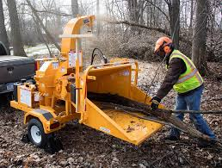
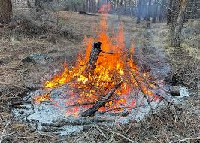
The disposal, including burning or removal to a site approved by the Local Jurisdiction, in consultation with the Fire Authority, of flammable vegetation and fuels caused by site construction, Road, and Driveway construction shall be in accordance with all applicable laws and regulations.

Special Consideration:
Burning of vegetation in any area requires a permit from the Air Quality Management District. Permits may be available online. Follow the link below that lists all the Air Districts to find the area you are in.

https://ww2.arb.ca.gov/california-air-districts



THIS GUIDELINE IS FOR INFORMATIONAL USE ONLY
Illustrations and Example within this guideline are artist renderings, not to scale

View the official California Code of Regulations online at https://govt.westlaw.com/calregs

